SUBCOURSE EDITION
AV0568 A

US ARMY AVIATION CENTER

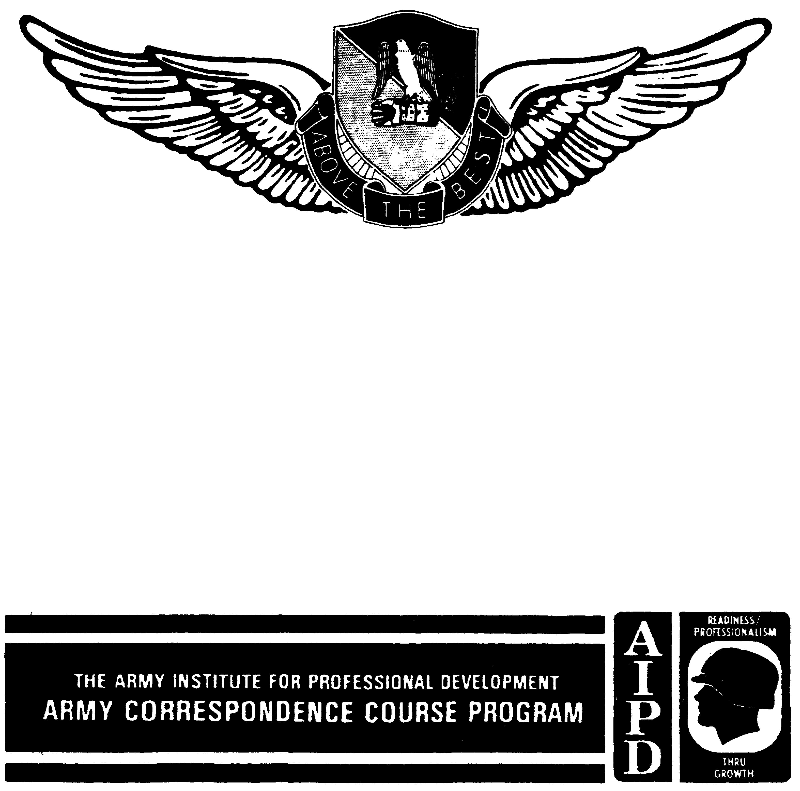

AVIATION ACCIDENT PREVENTION

THIS SUBCOURSE HAS BEEN REVIEWED FOR OPERATIONS SECURITY CONSIDERATIONS.

AVIATION ACCIDENT PREVENTION

Subcourse Number AV 0568

EDITION A

United States Army Aviation Center
Fort Rucker, Alabama 36362-5000

9 Credit Hours

Edition Date: December 1992

SUBCOURSE OVERVIEW

Aviation safety is only a part of the Army's safety program and interacts with other specific activities. The first two lessons therefore, deal with overall objectives of the Army's safety program. All of the lessons are based on the actual regulations that pertain to safety practices and procedures. Aviation safety cannot be left to various opinions and interpretations of what should be done. Regulations that describe policies and procedures for mishap prevention, and particularly aviation mishap prevention, are clear, precise, and complete. Knowledge of and adherence to these regulations are necessary to complete any assigned mission. Some publications are substituting the word mishap for accident.

No prerequisites exist for this subcourse.

This subcourse reflects the current doctrine when it was prepared. In your own work, always refer to the latest publications.

Unless otherwise stated, the masculine gender of singular pronouns refers to men and women.

TERMINAL LEARNING OBJECTIVE

ACTION: You will become familiar with the US Army causation model and label system deficiencies in relation to that model and will identify model term definitions and principles. You will become familiar with the US Army accident prevention process, identify the steps

AV0568
in the process, and identify actions performed in each step. You will become familiar with command and individual responsibilities and duties toward safety. You will become familiar with the contents of the Guide to Aviation Resources Management for Aircraft Mishap Prevention and how it is used when conducting the aircraft accident prevention survey. This Guide is prepared by the Aviation Branch Safety Office, US Army Aviation Center,

CONDITION: You will use the material in this subcourse.

STANDARD: To prove competency of this task, you must achieve a minimum of 70 percent on the examination.

AV0568
TABLE OF CONTENTS

Section Page

Lesson 1: CAUSATION ANALYSIS 1-1

Early Views 1-2
Heinrich's Domino Theory 1-2
US Army Causation Model 1-2
Countermeasure Potential 1-6
System Definition 1-7
Practice Exercise 1-13
Answer Key and Feedback 1-15

Lesson 2: THE ACCIDENT PREVENTION PROCESS 2-1

Information Collection 2-2
Causation Analysis 2-4
Countermeasures 2-6
Implementation 2-12
Control 2-14
Practice Exercise 2-15
Answer Key and Feedback 2-17

Lesson 3: RESPONSIBILITIES AND DUTIES 3-1

Commander's Responsibility 3-1
Staff Responsibility 3-3
Individual Responsibility 3-3
Practice Exercise 3-11
Answer Key and Feedback 3-13

Lesson 4: AIRCRAFT ACCIDENT PREVENTION SURVEY 4-1

The Survey 4-2
Aviation Branch Safety Office, US Army
Aviation Center 4-2

i AV0568
Section Page

Practice Exercise ............... 4-5

Answer Key and Feedback ............ 4-6

ii AV0568
LESSON 1

CAUSATION ANALYSIS

Critical Task: None

OVERVIEW

LESSON DESCRIPTION:

You will become familiar with the US Army Causation Model and will identify system deficiencies in relation to the model as well as model term definitions and principles.

TERMINAL LEARNING OBJECTIVE:

ACTION: You will become familiar with the US Army Causation Model, will label system deficiencies in relation to the model, and will identify model term definitions and principles.

CONDITION: You will use the lesson text to complete the action.

STANDARD: You will become familiar with the US Army Causation Model, will label system deficiencies in relation to the model, and will identify model term definitions and principles according to this lesson.

REFERENCE: The material in this lesson was derived from the following publication: Theories of Safety Management, US Army Safety Center (USASC) Safety Management Concepts Series (reprinted February 1990).

INTRODUCTION

Traditional accident causation models have focused on the unsafe act or unsafe condition as the cause of accidents. Remedial action was directed at the unsafe act or condition. The DA has developed an accident causation model that goes further in depicting the causes of accidents. This model stresses that defects in the organizational system are the cause of accidents. Use of the US Army Causation Model in analyzing safety deficiencies allows the organization to eliminate the root causes (system defects) of these deficiencies. To understand the progress that has been made in accident prevention, consider the following:

1-1 AV0568
1. EARLY VIEWS

If while walking through the forest the primitive man was struck on the head by a tree limb, he could only reason that the spirits were angry with him. With this cause, his only accident prevention method was to appease the tree spirits. Later, during the industrial revolution, a more sophisticated view prevailed. The person injured was at fault because he was careless or stupid. Accidents were considered a natural side effect of production, and it was the individual's responsibility to take care of himself. Employers believed that human nature made accidents inevitable. They also knew that they could replace an injured worker. This was convenient reasoning, because then it was obviously unnecessary for managers to do anything about accident prevention. Public opinion gradually changed this method of employee exploitation. By 1908 every state had an employer liability law. With this assumption of financial responsibility by the employer came the first serious efforts at accident prevention; however, with no previous experience to base these efforts on, the results were poor.

2. HEINRICH'S DOMINO THEORY

In 1931, H. W. Heinrich published a book called Industrial Accident Prevention, A Scientific Approach. He proposed a model to analyze an accident sequence (Figure 1-1) that has remained the basis for most accident prevention efforts since. His model worked back from the injury and accident to focus on the unsafe act or unsafe condition as the point of attack in accident prevention. This theory has been labeled the "domino theory." The accident prevention effort consisted of removing a domino to keep the rest of the sequence from falling down. In concentrating on the unsafe condition, managers could look at machine design, task layout, and other safety features to make it unlikely that an employee mistake would result in injury. In concentrating on the unsafe act, education, persuasion, and worker motivation were the tools. The next step in Heinrich's model--fault of person--places the blame on the individual once again. It is here that the US Army Causation Model leaves from Heinrich to focus on the system-rooted causes of accidents.

3. US ARMY CAUSATION MODEL

The US Army Causation Model (Figure 1-2) initially parallels Heinrich's model. Terminology is changed and slight changes of definitions are made. The US Army Causation Model, however, makes a radical change with the introduction of the concept of system defects, the keystone of this model.

1-2 AV0568
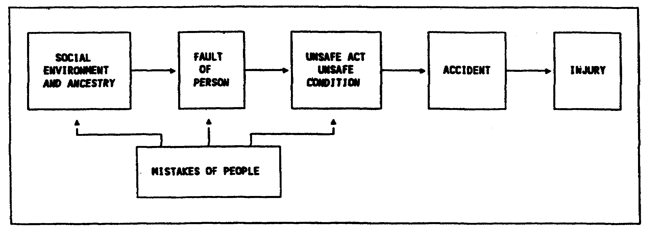

Figure 1-1. Heinrich's "domino theory"

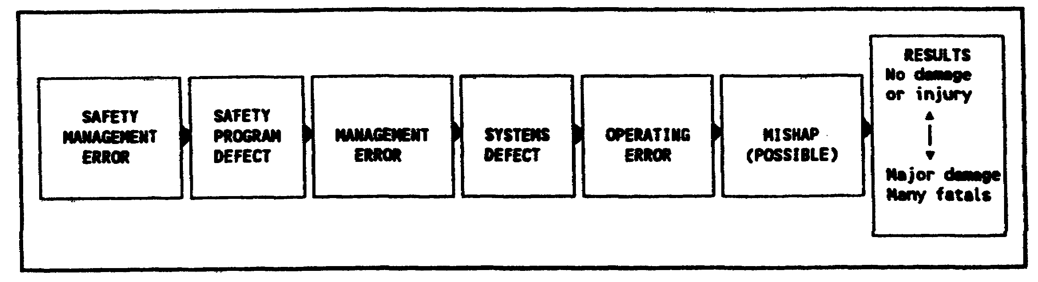

Figure 1-2. The US Army Causation Model

a. Model Term Definitions and Principles

To illustrate the model, we will consider a worker at a construction site. A brick falls and hits a worker on the head as he walks under a scaffold.

(1) Result

The term "result" is used in this model to allow for damage as well as injury. It also shows the variability of the result--from no damage or injury to major damage or injury. In the accident prevention effort, those mishaps that, through chance, don't produce damage are as good an indicator of problem areas as catastrophic accidents. They also are less costly to analyze. In the illustration, the result (US Army Causation Model) and injury (Heinrich) are the same--a head injury.

1-3 AV0568
(2) Mishap

(a) A mishap is defined as an unplanned event. It does not imply damage or injury. This allows for those "near misses" that don't fit the US Army's definition of an accident (an unplanned event that results in damage or injury). In the illustration, if the brick had fallen one second earlier or the worker had been in position one second later, a mishap still would have occurred, but there would have been no accident. There may be many such mishaps before chance allows an accident to occur.

(b) All mishaps result from hazardous situations created by operating errors, all of which involve the acts of people. Thus all unsafe acts are committed by people and all unsafe conditions are created by acts of people. Unsafe acts create unsafe conditions and unsafe conditions permit unsafe acts.

(3) Operating Error

The term "operating error" is used to join unsafe acts and unsafe conditions together as mistakes of individuals. In the illustration, the unsafe conditions might be a lack of a toeboard to keep bricks from slipping over the edge of the scaffold or a lack of a restricted area underneath the scaffold. Unsafe acts would be walking under the scaffold and not wearing a hard hat. The US Army Causation Model departs from Heinrich's at the cause of operating errors. Operating errors are caused by two factors: the personality defects of people (about which we can do very little in practical terms) and system defects (that we can do a great deal about).

(4) System Defects

The US Army Causation Model adds a concept that virtually revolutionizes accident prevention work, that of system defects. System defects are weaknesses in the way a system is designed or operated. The system defect is the key concept of this model. An organizational system is simply a group of interrelated parts that, when working together as they were designed to do, accomplish a goal. The system parts used in this model analysis are described in paragraph 5 of this lesson. In the illustration, we might ask why a scaffold was purchased without a toeboard. Are safety specifications not considered in the acquisition process? Is there a standard procedure for the erection of scaffolds? Does it include restricted areas? Are hard hats available? Is their use enforced? Is there adequate supervision and expertise? Questions such as these broaden the scope of the inquiry. If there were no safety specifications in this purchase, what other equipment could be

1-4 AV0568
deficient? If the workers lack training in this area, in what other areas are they weak?

(5) Management Error

The concept of system defects puts the burden on management. Management error is the cause of system defects because managers are the people who design and operate systems. Reasons for management error include the manager is not properly motivated, is not assigned responsibility, and is not knowledgeable or capable. In the illustration, if the supervisor was not tested on his safety record, he would have no reason to make the necessary system changes. He may have been incapable of implementing change because of too large a span of control or a lack of skill. He may have lacked the knowledge, or access to the knowledge, of safety specifications and procedures. This deficiency would lead us to the next block in the model.

(6) Safety Program Defect

A safety program defect is a defect in some aspect of the safety program that allows a management error to exist. The accident prevention process recommended by the US Army Safety Center consists of five steps: information collection, causation analysis, countermeasure proposal, implementation, and controls. The accident prevention process will be introduced in the next lesson. In the illustration, if there had been no formal information collection of previous mishaps, management would not be aware of the defects. Information collection should cover the whole spectrum of the causation model sequence. If information is collected only from results, valuable data is being ignored. If the information was collected but not analyzed for root causes (system defects), it would have the same result as picking leaves off a tree--the root causes would still be there and the leaves (defects) would reappear. If countermeasures are developed and implemented using the causation model, the system defects causing the errors can be dropped, such as safety specifications in acquisition, training program for workers, detailed assignment of supervisory responsibilities. In addition to accident prevention, this process has the added benefit of aiding mission accomplishment through better management.

(7) Safety Management Error

The safety manager's sole job is designing a safety system the sole output of which is advising management on ways to cut the causes of operating errors. The problem is not how to end accidents, not how to end operating errors, but rather how to end the management-rooted causes of operating errors. A safety management error is a weakness in the knowledge or motivation of the safety manager that permits a safety program defect to exist. A safety manager that is not trained in

1-5 AV0568
methods of causation analysis or in the required safety specifications of his or her system will be incapable of advising management on effective improvements in the system. The process of constantly "picking the same leaves" (operating errors) will seem a fruitless task. Using the US Army Causation Model will provide the safety manager with tangible as well as intangible rewards.

b. US Army Causation Model Versus Heinrich's

(1) The US Army model stresses the variability of result, Heinrich's does not.

(2) The US Army model identifies the chance, not inevitability, of the accident or mishap.

(3) The US Army model stresses the identity of unsafe acts and unsafe conditions, calling both operating errors.

(4) The US Army model identifies the system origin of operating errors, an aspect totally overlooked in Heinrich's model.

(5) The US Army model shows the staff role of safety manager and recognizes his or her responsibility to line management.

4. COUNTERMEASURE POTENTIAL

a. The US Army Causation Model allows eight points of attack to alter or halt the mishap sequence. Although the system defect is the key point of concentration, a broadband attack with countermeasures devised for as many blocks as possible will allow management to implement the most practical countermeasures.

(1) Countermeasures under result would normally include damage-limiting functions such as availability of medical aid and fire fighting to moderate the results of a mishap.

(2) If mishaps are considered inevitable, it might be advisable to provide protective equipment such as a hard hat. Protective barriers also might be employed. As a last resort, consideration might be given to separating the worker from the activity with remote control devices.

(3) To correct operating errors involves correcting the immediate unsafe act or condition. For those hazards that present immediate catastrophic danger, on-the-spot corrections are required until system-rooted causes can be addressed.

1-6 AV0568
(4) System defects are corrected through a redesign of one or more of the elements of the system (para 5): task, training, person, environment, and materiel.

(5) Countermeasures for management error and safety management error consist of training, motivation, and task design.

(6) Proper implementation of the accident prevention process using the concepts described in Lesson 2 will help address any safety program defect. Using the causation model will provide the type of information that warrants management attention.

(7) The model shown in Figure 1-3 adds the eighth factor of inherited or gained personal characteristics. This accounts for those operating errors caused by personality defects. In this case, the traditional three E's--engineering and design, education and training, and enforcement and motivation--would NOT provide the desired result.

b. The eight avenues open so many effective countermeasures to the safety manager that the problem becomes selecting the best total combination consistent with available resources. The system defect should be keyed to prevent recurrence of the problem. All available countermeasures, however, should receive consideration.

5. SYSTEM DEFINITION

You have been introduced to the US Army's model for depicting the causes of accidents and deficiencies of a system as they relate to the model. Now let's look at an organizational system and how that system is designed.

a. Viewing an Organization as a System

As stated earlier, a system is simply a group of interrelated parts that, when working together as they were designed to do, accomplish a goal--movement from one place to another. There are, of course, many subsystems within a total system. In a car, there is the braking subsystem, the ignition subsystem, and such. If any of these subsystems within the total system of the automobile malfunctions, the mission of the total system is hindered--the car will not run properly.

(1) In comparison, an installation or organization can be viewed as a system. Like an automobile, an installation is a group of interrelated parts and, again like an automobile, it has a goal or mission.

1-7 AV0568
(2) An installation has an input of resources, that is all the people, money, and materiel at the disposal of the installation commander. An installation also has output--the goal or mission to be accomplished by that installation commander with the resources available. All installations have this input and output aspect. With a given amount of resources, an installation commander is to accomplish a given mission.

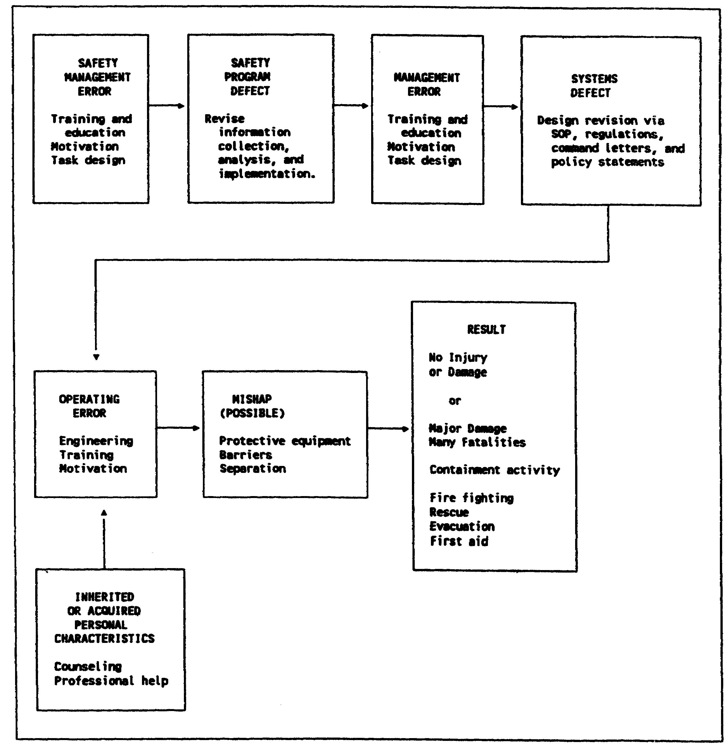

Figure 1-3. Us Army Causation Model countermeasure potential

1-8 AV0568
(3) To take a more in-depth look at the idea of an installation as a system, let's suppose that General Smith has just taken command at Fort X. General Smith has been given a mission to accomplish. Depending on the installation, that mission may be a certain number of combat soldiers trained per year, it may be so many units of ammunition manufactured per month, or it may be some other mission. General Smith knows before arriving at Fort X what is to be accomplished with the new command. This mission is the output when viewing Fort X as a system. On arrival at Fort X, General Smith will want to know how much money can be spent to perform the mission, how many people will be available to accomplish the mission, and what materiel the fort now has with which to reach the goal of mission accomplishment. Thus, General Smith will need to know the input into the installation or system to arrive successfully at the output of mission accomplishment. With these two sets of information, General Smith is ready to design available resources in the best, most efficient way to reach the goal. Therein lies a commander's responsibility--to take the resources available and design them so the mission can be efficiently and economically accomplished. The words efficient and economic are keywords in a commander's task.

NOTE: The safety staff exists only to advise line management on the design and operation of a safety program.

b. Designing a System

The design of the system is very important in efficiently and economically accomplishing the mission. The US Army Institute of Administration (USAIA) systems model shown in Figure 1-4 gives a more detailed look at the arrangement of the parts.

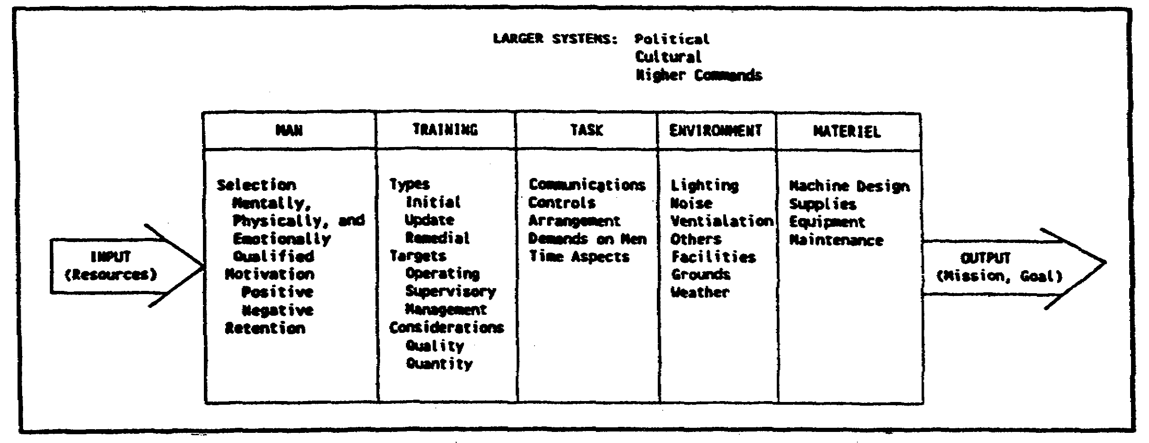

Figure 1-4. USAIA systems model

1-9 AV0568
(1) When designing an installation to perform a total mission, you must first decide what tasks need to be done. The Army or any other organization designs its installation or business in this manner. First, the duties or tasks necessary to accomplish the overall mission are determined. Next, a person or "man" is hired to accomplish each of the tasks decided upon. The person hired has to have certain skills or abilities that are considered important to perform successfully the task for which he or she was hired. After hiring the person, though, you must give the employee additional training so not only general duties but also those that are specific to "this job in this place" are known by that person. Once the person has been trained to perform a specific job, he or she is placed in the environment in which the job is to be performed and given the materiel necessary to perform the job.

(2) When an installation, or any organization, is thus viewed as a system, it is easy to see that something may go wrong in the design of that system. For instance, the task originally was designed poorly. Perhaps the demands on the person to perform the task are in error or the time given the person in which to perform the task is inadequate. or, the way the task is arranged makes it difficult for any person, no matter how well trained, to perform it. It is easy to see that sometimes an error or defect can erroneously be built into a job, thereby making it difficult to perform at all, let alone perform safely.

(3) Other sections of the systems model also can develop defects. The person selected for the task can be mentally, physically, or emotionally unable to perform the task. The person may not be motivated, either positively or negatively, to do the job for which he or she was hired. Another problem that sometimes occurs, probably more frequently with military personnel, is that of retention. Young military officers are assigned for a brief time to particular jobs and before they can learn them well, they are rotated to other positions. These problems can and sometimes do create defects in the efficient and economic design of the system.

(4) Several defects can creep into the training aspect of the system. A person can be given the wrong type of training. The employee may be given initial training but does not receive the update training required to keep the top level of proficiency. Maybe the person does not reach the proficiency needed in the initial training and, therefore, should receive remedial training. Sometimes the training itself is excellent but is aimed at the wrong group. Supervisors are trained when operating personnel should be trained. Perhaps supervisors and operators are trained, but managers are not and should have been. Another problem with training is the quality versus quantity aspect. It sometimes happens that the quality of training is excellent but not enough time or too

1-10 AV0568
much time is spent to bring the trainees to the level of skill needed. Though the task is well designed and the person selected to perform the task is an excellent choice, these errors in training the employee can lead to defects in the system or installation that can cause losses of one kind or another.

(5) Defects also can occur in the environment aspect of the system design. the lighting or ventilation is inadequate when performing a task, or the noise level is too high. Sometimes weather is a big factor when doing a job. The employee can do a job beautifully in one climate but cannot do it at all in another. The way the installation grounds and facilities were originally built or laid out can sometimes make it extremely difficult for an employee to do his or her job in an efficient, safe manner. These problems, and others you may think of, create defects in the installation or system.

(6) A big problem area within the system is frequently that of materiel. The supplies and equipment given the person to perform a task are sometimes poorly designed or, even more often, poorly kept. To do a job well, an employee must be given properly designed and kept equipment and supplies. All too frequently, because of budget restrictions or other reasons, this is not done. A defect then exists in the materiel aspect of the system.

1-11 AV0568
LESSON 1

PRACTICE EXERCISE

The following items will test your grasp of the lesson material. Each item has only one correct answer. When you complete the exercise, check your answers with the answer key that follows. If you answer any item incorrectly, restudy that part of the lesson.

REQUIREMENT: In items 1 through 7, use the causation model depicted below. Match the letter of each defect to the proper element.

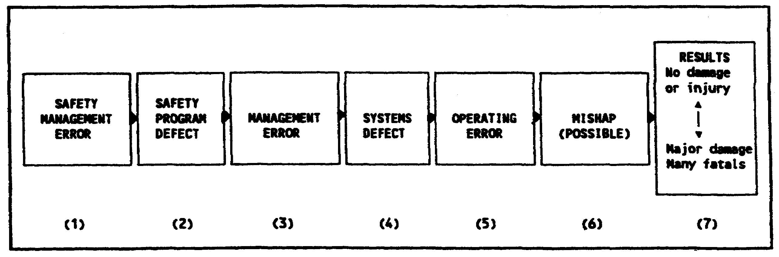

1. A. Unit safety officer is not school trained.
2. B. Service member's left hand cut off by tire rim.
3. C. Unit safety program did not include surveys of work area.
4. D. Service member was struck by metal rim when tire exploded.
5. E. Service member took high pressure tire apart without first letting air out.
6. F. Maintenance supervisors were playing cards in maintenance office at time of explosion.
7. G. Maintenance personnel routinely perform maintenance operations without the proper maintenance manuals.

1-13 AV0568
8. The key concept of the US Army Causation Model (the cause of operating errors) is the

A. mishap.
B. result.
C. system defect.
D. safety program error.

9. The US Army Causation Model stresses individual responsibility for accidents.

A. true
B. false

10. A mishap that does not result in damage or injury is a good indicator of a problem and should be reported.

A. true
B. false

1-14 AV0568
LESSON I

PRACTICE EXERCISE

ANSWER KEY AND FEEDBACK

Item Correct Answer and Feedback

1. A. Unit safety officer is not schooled trained.

The safety management error is caused by a weakness in the knowledge of the safety manager that permits a safety program defect to exist. School training will prevent this type of error. (page 1-5, para 3a(7))

2. C. Unit safety program did not include surveys of work area.

The safety program defect is a defect in some aspect of the safety program that allows a management error to exist. Lack of surveys in a unit safety program is a program defect error. (page 1-5, para 3a(6))

3. F. Maintenance supervisors were playing cards in maintenance office at the time of explosion.

The management error is the cause of system defects because managers are the people who design and operate systems. Playing cards instead of monitoring the operation and safety of a task indicates lack of motivation and supervision. (page 1-5, para 3a(5))

4. G. Maintenance personnel routinely perform maintenance operations without appropriate maintenance manuals.

System defects are weaknesses in the way a system is designed or operated. If personnel are routinely performing tasks against established policy or procedure, this indicates a problem in the way that the system is designed and/or enforced. (page 1-4, para 3a(4))

1-15 AV0568
5. E. Service member took high pressure tire apart without first letting air out.

An operating error is used to join unsafe acts and conditions together as mistakes of individuals. The operating error is the act which is unsafe. System defects are the cause of operating errors. (page 1-4, para 3a(3))

6. D. Service member was struck by metal rim when tire exploded.

Mishap is defined ad an unplanned event. It does not necessarily imply damage or injury. It allows for those "near misses" that don't fit the US Army's definition of an accident. (page 1-4, para 3a(2))

7. B. Service members's left hand cut off by tire rim.

Results are the outcome of the safety error. It may range from no damage or injury (mishap) to major damage or fatalities (accidents). (page 1-3, para 3a(1))

NOTE: Answers 1 through 7 can be summarized as follows: The unit safety officer was not school trained in methods of causation analysis (safety management error). No surveys were included in the unit safety program to warn of potential problems (safety program defect). Supervisors were playing cards instead or monitoring operations (management error). Unsafe acts were being routinely performed (system defect). An unsafe act was performed (operator error). The event occurred when an unsafe act was performed--the tire exploded and the rim flew off (mishap). The service member's hand was cut off (result). (page 1-3, para 3a)

8. C. system defect.

Mishap and result are the outcomes of an error. A safety program error is not a term used in the US Army Causation Model. System defects are weaknesses in the way a system is designed or operated that cause operating errors. (page 1-4, para 3a(4))

9. B. false

The US Army Causation Model stresses system defects as the cause of accidents and management error as the cause of system defects (not the individual operator). (page 1-1, INTRODUCTION; and page 1-5, para 3a(5))

1-16 AV0568
10. A. true

Near misses (mishaps) that could have resulted in damage or injury indicate that a problem exists that should be reported, especially if all procedures were being performed "by the book." (page 1-3, para 3a(1))

1-17 AV0568
LESSON 2

THE ACCIDENT PREVENTION PROCESS

Critical Task:

OVERVIEW

LESSON DESCRIPTION:

This lesson will help you become familiar with the US Army accident prevention process and identify the steps in the process and the actions performed in each step.

TERMINAL LEARNING OBJECTIVE:

ACTION: You will know the US Army accident prevention process, identify the steps in the process, and identify actions performed in each step.

CONDITION: You will use the lesson text to complete the action.

STANDARD: You will know the US Army accident prevention process and identify the steps in the process and the actions performed in each step according to this lesson.

REFERENCE: The material in this lesson was derived from the following publication: AR 385-10 and Theories of Safety Management, USASC Safety Management Concepts Series (reprinted February 1990).

INTRODUCTION

The US Army causation model discussed in Lesson 1 provides a method to identify root causes of accidents and mishaps (system defects). It also opens eight avenues through which we can begin countermeasures. The accident prevention process is an outline of the process required to gather and analyze deficiencies and to devise and carry out effective countermeasures. Elimination of the management-rooted causes of operating errors is the goal of the accident prevention process.

In Lesson 1 a model was introduced to analyze deficiencies. A process is needed now to provide input for the model analysis and a method to correct the identified defects. The output of this process should be directed to the goals and objectives of the Army Safety Program. The accident

2-1 AV0568
prevention process in this lesson is a five-step process (Figure 2-1). It describes the full-time duties of the safety officer and may be employed by others.

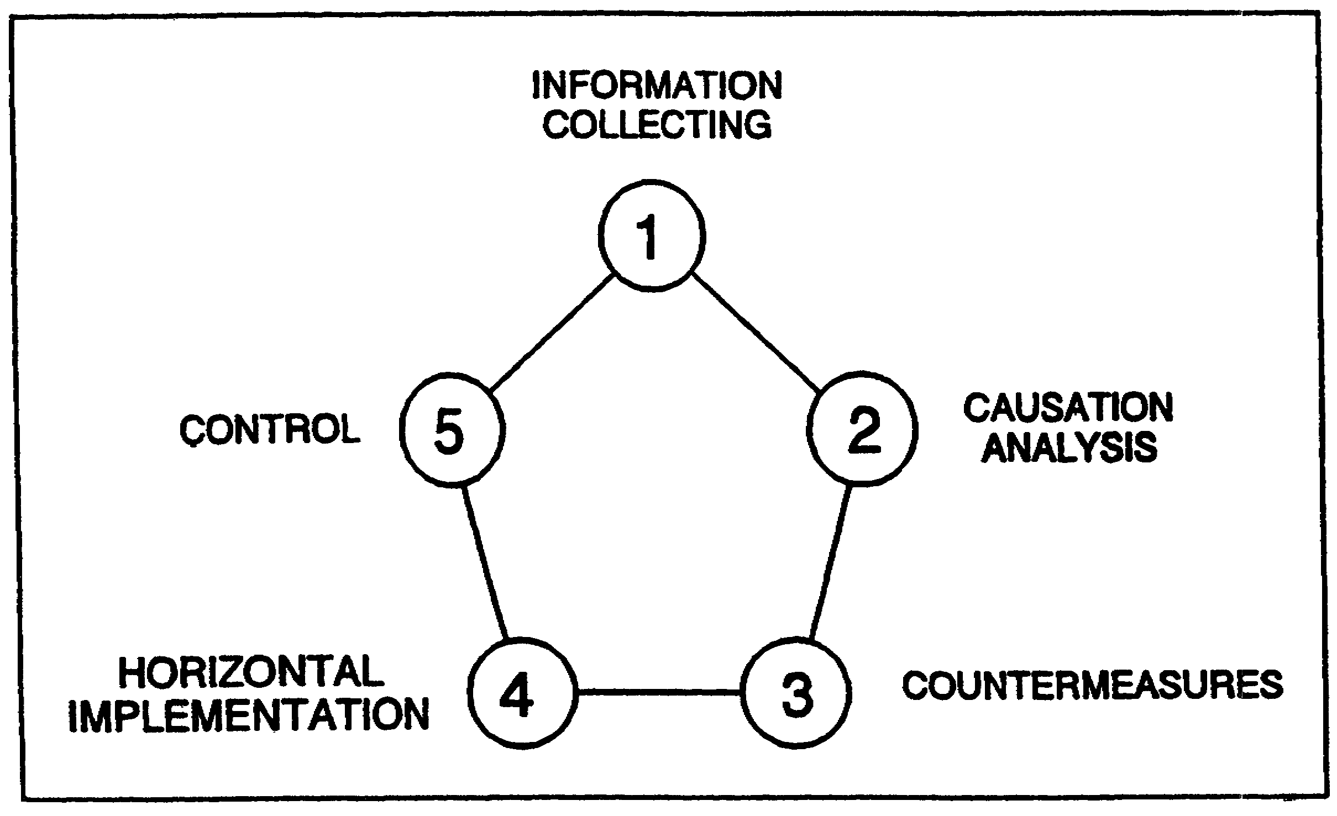

Figure 2-1. Accident prevention process

1. INFORMATION COLLECTION

To design effectively and operate a safety program, the safety officer must know what is happening throughout the organization. An information collection system must be designed and managed to know what has happened, what is happening, and what can be expected to happen. Good information collection requires a knowledge of this prevention process and the organizational system.

a. Information should be collected from all aspects of the causation model sequence. Detection of defects in the managerial blocks of the causation model sequence (systems defects, management error, safety program defect, and safety management error) gives the advantage of leverage. Each weakness detected has probably been causing many operating errors, mishaps, and accidents. Information on each segment is necessary. A list of these segments and the information required is in Figure 2-2.

2-2 AV0568
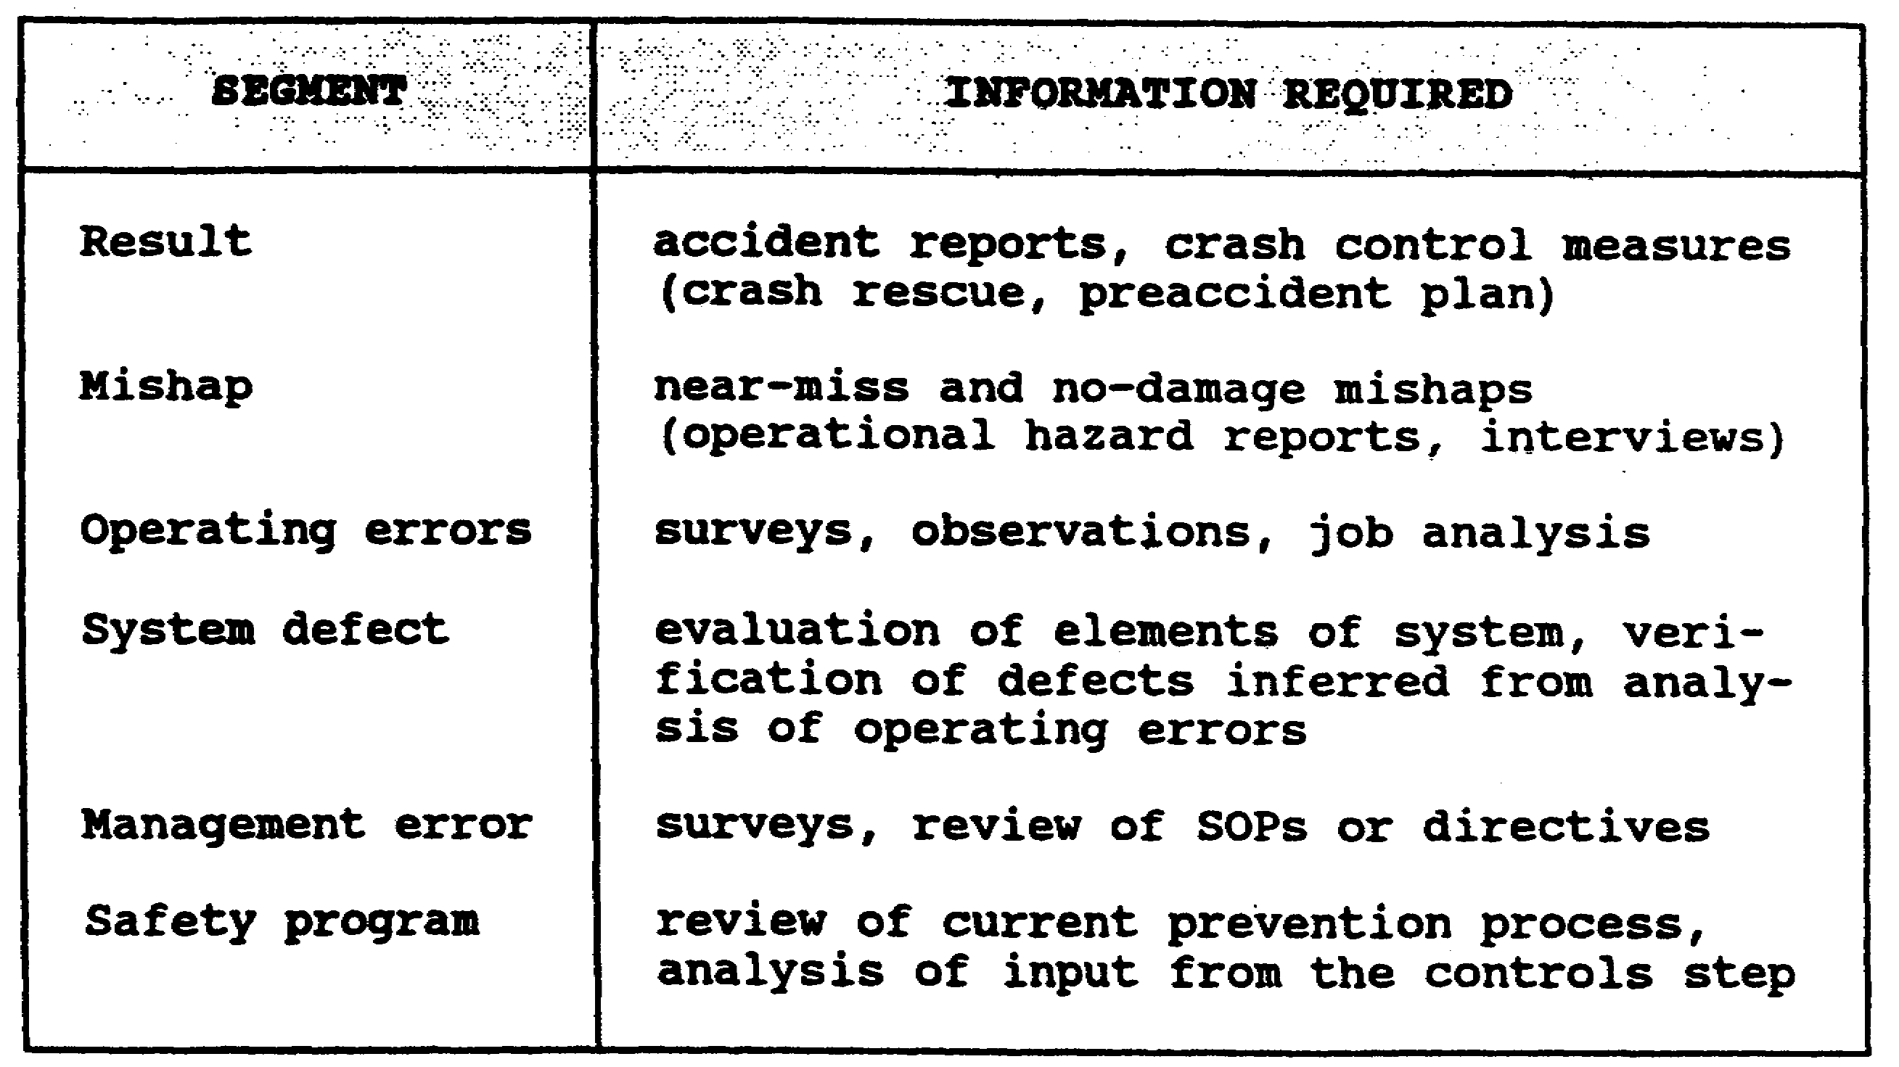

Figure 2-2. Causation model segments

b. A variety of information sources should be used. Some sources will provide a more balanced and representative sample as well as cross-checks. Some of the sources available are—

(1) Accident reports.

(2) Job hazard analysis.

(3) Operational hazard reports.

(4) Questionnaires (low net cost, limited only by creativeness).

(5) The control's input (monitor and check previously made countermeasures).

(6) Interviews--on-the-job and exit (not used enough; good for detecting near-miss incidents and unsafe acts).

(7) Surveys--USASC Commander's Guide to Aviation Resources Management for Aircraft Mishap Prevention.

(8) Inspections--annual general inspection, Aviation Resource Management Survey, Occupational Safety and Health Administration, and fire marshal.

2-3 AV0568
c. There are seven factors that should be evaluated in determining the emphasis to be placed on an information source. These factors are—

(1) Upward communication--operators are the experts.

(2) Consistent data processing--for large amounts of data.

(3) Before-the-accident data--prevention versus reaction.

(4) Efficiency--use cheapest if two sources provide the same data.

(5) Priorities--determine whether the source focuses attention on problems warranting priority.

(6) Control over the volume and source of data--statistically valid volume, targeted at priorities.

(7) Education and motivation--leave the individuals involved with a favorable attitude and more knowledgeable.

d. Information is the lifeblood of the safety program. In developing an information collection system, the basic considerations include targeting, priorities, and economics. Targeting assures that information is drawn from all aspects of the system. Priorities see that more information comes from the more hazardous operations. Economics gets information as inexpensively as practical.

2. CAUSATION ANALYSIS

Raw information is of little value. The information must be correlated and analyzed to form groups of relevant data.

a. Correlate Data

Correlation of data involves looking for common denominators and relationships.

EXAMPLE: A group of inspections might reveal several shops with tools not calibrated, jacks not weight-tested, and safety guards missing on equipment.

b. Complete the Causation Model Sequence (Figure 2-3)

Completion normally involves taking a single operating error or group of operating errors and identifying the system defects and management errors that cause them. You also may start with management

2-4 AV0568
error and system defect and identify mishaps and accidents that are most likely to result from that error. This allows you to identify the scope of a problem. A system defect identified by one operating error may be causing many other operating errors. If lack of training is identified in one operating error, how many other operating errors are caused by the same system defect? The better you know your system or organization, the more accurately and easily you can complete the causation sequence. The jump from operating error to system defect is system specific. It depends on how your organization is set up and operates. Remember, in identifying system defects we are asking, what in the system defect allowed the unsafe act or unsafe condition to exist? In the illustration given earlier to illustrate the causation model (Lesson 1, para 3a), the system defect might be the lack of a written equipment maintenance program or the lack of specific assigned responsibility to carry out a program.

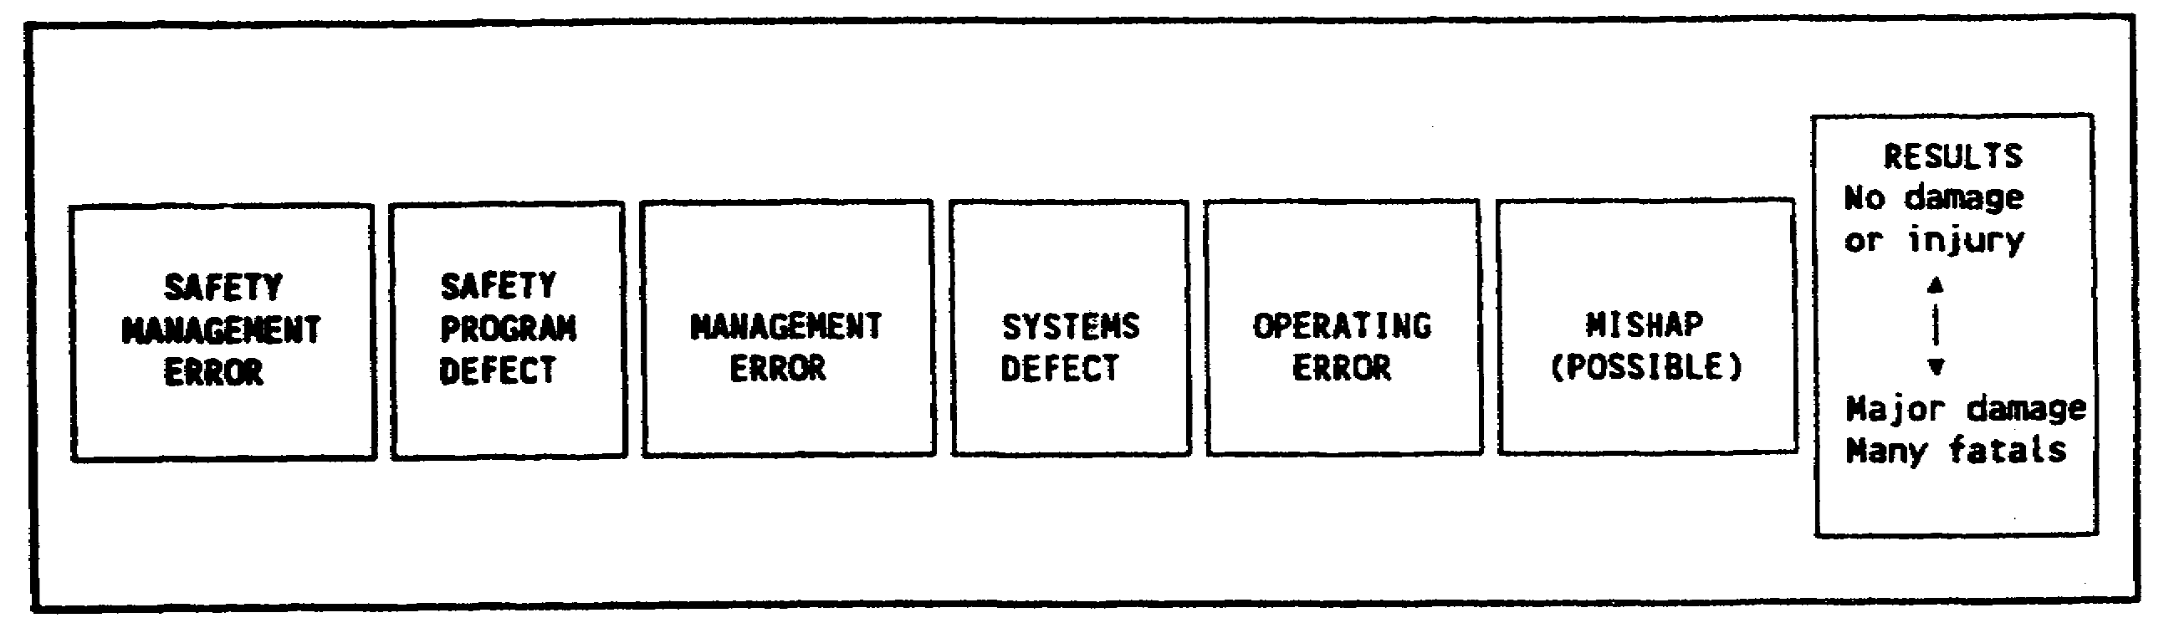

Figure 2-3. Causation sequence

c. Verify system Defects

After completing the causation sequence, you must be sure of any system defects that are based on a guess. It also is important to identify the full scope of the problem. Don't just stop at the first identified system defect. If lack of training is identified, personnel selection also might be involved. Task design could also be a factor. Causation analysis is not just a mental exercise. After making a list of what could cause the problem, research and be sure system defects and causes.

d. Set Priorities for Countermeasures

If the prevention process has performed well to this point, a wealth of worthwhile problems will be identified.

2-5 AV0568
Several factors must be considered in setting priorities for correction.

(1) Risk Assessment

Normally, risk assessment (Table 2-1) is conducted according to the safety program objectives (injury prevention, damage control, legal requirements, mission protection, and liability limitations) and a severity and chance assessment.

(2) Susceptibility Countermeasures

If a defect is readily subject to correction with little resource cost, correct it.

(3) Special Interests

High visibility hazards that involve command or public interest will certainly increase attention.

(4) Relationship to Other Problems

If a solution is mission supportive and cures operational defects as well, it will merit priority.

(5) Cost Estimate

Limited resources require allocation. Frequently, the most effective countermeasure is not the most efficient. Sometimes a less costly remedy will be used.

EXAMPLE: training versus equipment redesign

3. COUNTERMEASURES

Once the defect is identified, corrective action must be devised. Countermeasures should be well targeted (aimed at system defect), cost effective, and mission supportive. There are three traditional avenues of accident prevention countermeasures (commonly called the three E's): engineering and design, education and training, enforcement and motivation.

a. Engineering and Design

This avenue includes task design and equipment design. It covers initial design and redesign or fixes. Equipment redesign as a safety countermeasure is often the most effective solution (such as wire-cutting systems on aircraft). Equipment redesign, however, is often a slow process and requires a long lead time. Many times education and training must be used until an equipment fix can be made. Task redesign involves

2-6 AV0568
looking for the safer or easier method of accomplishing a task. Possibly a simple solution such as providing a checklist or step-by-step instructions for a complex task. The redesign also could involve strict controls--continuous or periodic quality controls. Task design is especially important in those hazardous tasks that do not allow training by trial and error. There are five basic principles to follow in engineering for safety. They are—

(1) Knowing the Hazard

This requires the skill and experience of someone who has worked the particular job, equipment, or activity (system knowledge).

(2) Finding the Hazard

This involves use of supervisory personnel who have the skills and ability to detect the hazards.

(3) Eliminating Hazards that can be Eliminated

Reduce and remove unnecessary hazards.

(4) Guarding Against Hazards that Cannot be Eliminated

Teach correct procedures, awareness, necessary skills. Make provisions for an adequate number of competent supervisors.

(5) Avoiding the Creation of New Hazards

Assure hazards do not creep in. Assure new procedures don't bring new hazards, especially countermeasures designed to correct old hazards.

b. Education and Training

This is the most used and most abused countermeasure. often someone will perceive a problem and then direct that a class be taught on it. This may not always solve the problem.

(1) Training Need

Figure 2-4 contains a model to analyze performance problems. This model is an adaptation of the performance model presented by Robert F. Mager in his book Analyzing Performance Problems. In analyzing whether the deficiency is a skill problem Mager asks, "Could he do it if his life depended on it?" If the answer is yes, it is NOT a skill problem. It is a motivational problem. A class on wearing seat belts does little but waste valuable training time. If he could do it before

2-7 AV0568
but performance has deteriorated, it may be because of a lack of feedback or reinforcement. If there is extensive use with no feedback, bad habits creep in. This is the reason for aircraft standardization rides. If he could use it before, but performance has deteriorated because he does not use it often enough, arrange for practice between uses. An example of this method is the requirement to perform iterations of maneuvers required by the aircrew training manual. Another way to attack the performance problem is to simplify the task. If a simpler method is available, use it; if not, use aids such as checklists.

(2) Education Versus Training

Training is the process of developing skill in doing a job, performing an operation, or engaging in an activity. Education is the process of teaching discretion in performing a job, operation, or activity. In this connection, Army accidents are classified as two types--operational and nonoperational. Operational accidents, those that occur in the performance of duty, can be reduced rapidly by additional training and closer supervision. Nonoperational accidents, such as off-duty motor vehicle accidents, require education to teach people to act safely when not under supervision (when they are "on their own"). It is assumed that a soldier will have received adequate training for satisfactory performance of his or her various duties. So, military personnel with safety responsibilities should be more concerned with educational aspects of the safety problem. Three aspects of safety education and training are developing positive safety attitudes; imparting knowledge necessary for safe performance of various jobs, operations, and activities; and developing skill to the level necessary for safe performance. The first two aspects require education. The third aspect--skill development--is accomplished through training.

(3) Safety Knowledge

Knowledge of rules governing specific jobs, operations, and activities is essential for safe performance. A high degree of skill in manipulating a motor vehicle is not enough for safe driving. The driver also must have knowledge of traffic regulations, stopping distances at various speeds and under varying road and weather conditions, warning signals showing defective brakes and tires, effects of alcohol and fatigue on alertness and perception, and a long list of other pertinent factors. Possession of proper knowledge also helps in developing proper attitudes toward safety. Knowledge leads to understanding, and understanding leads to favorable attitudes.

2-8 AV0568
Table 2-1. Risk assessment

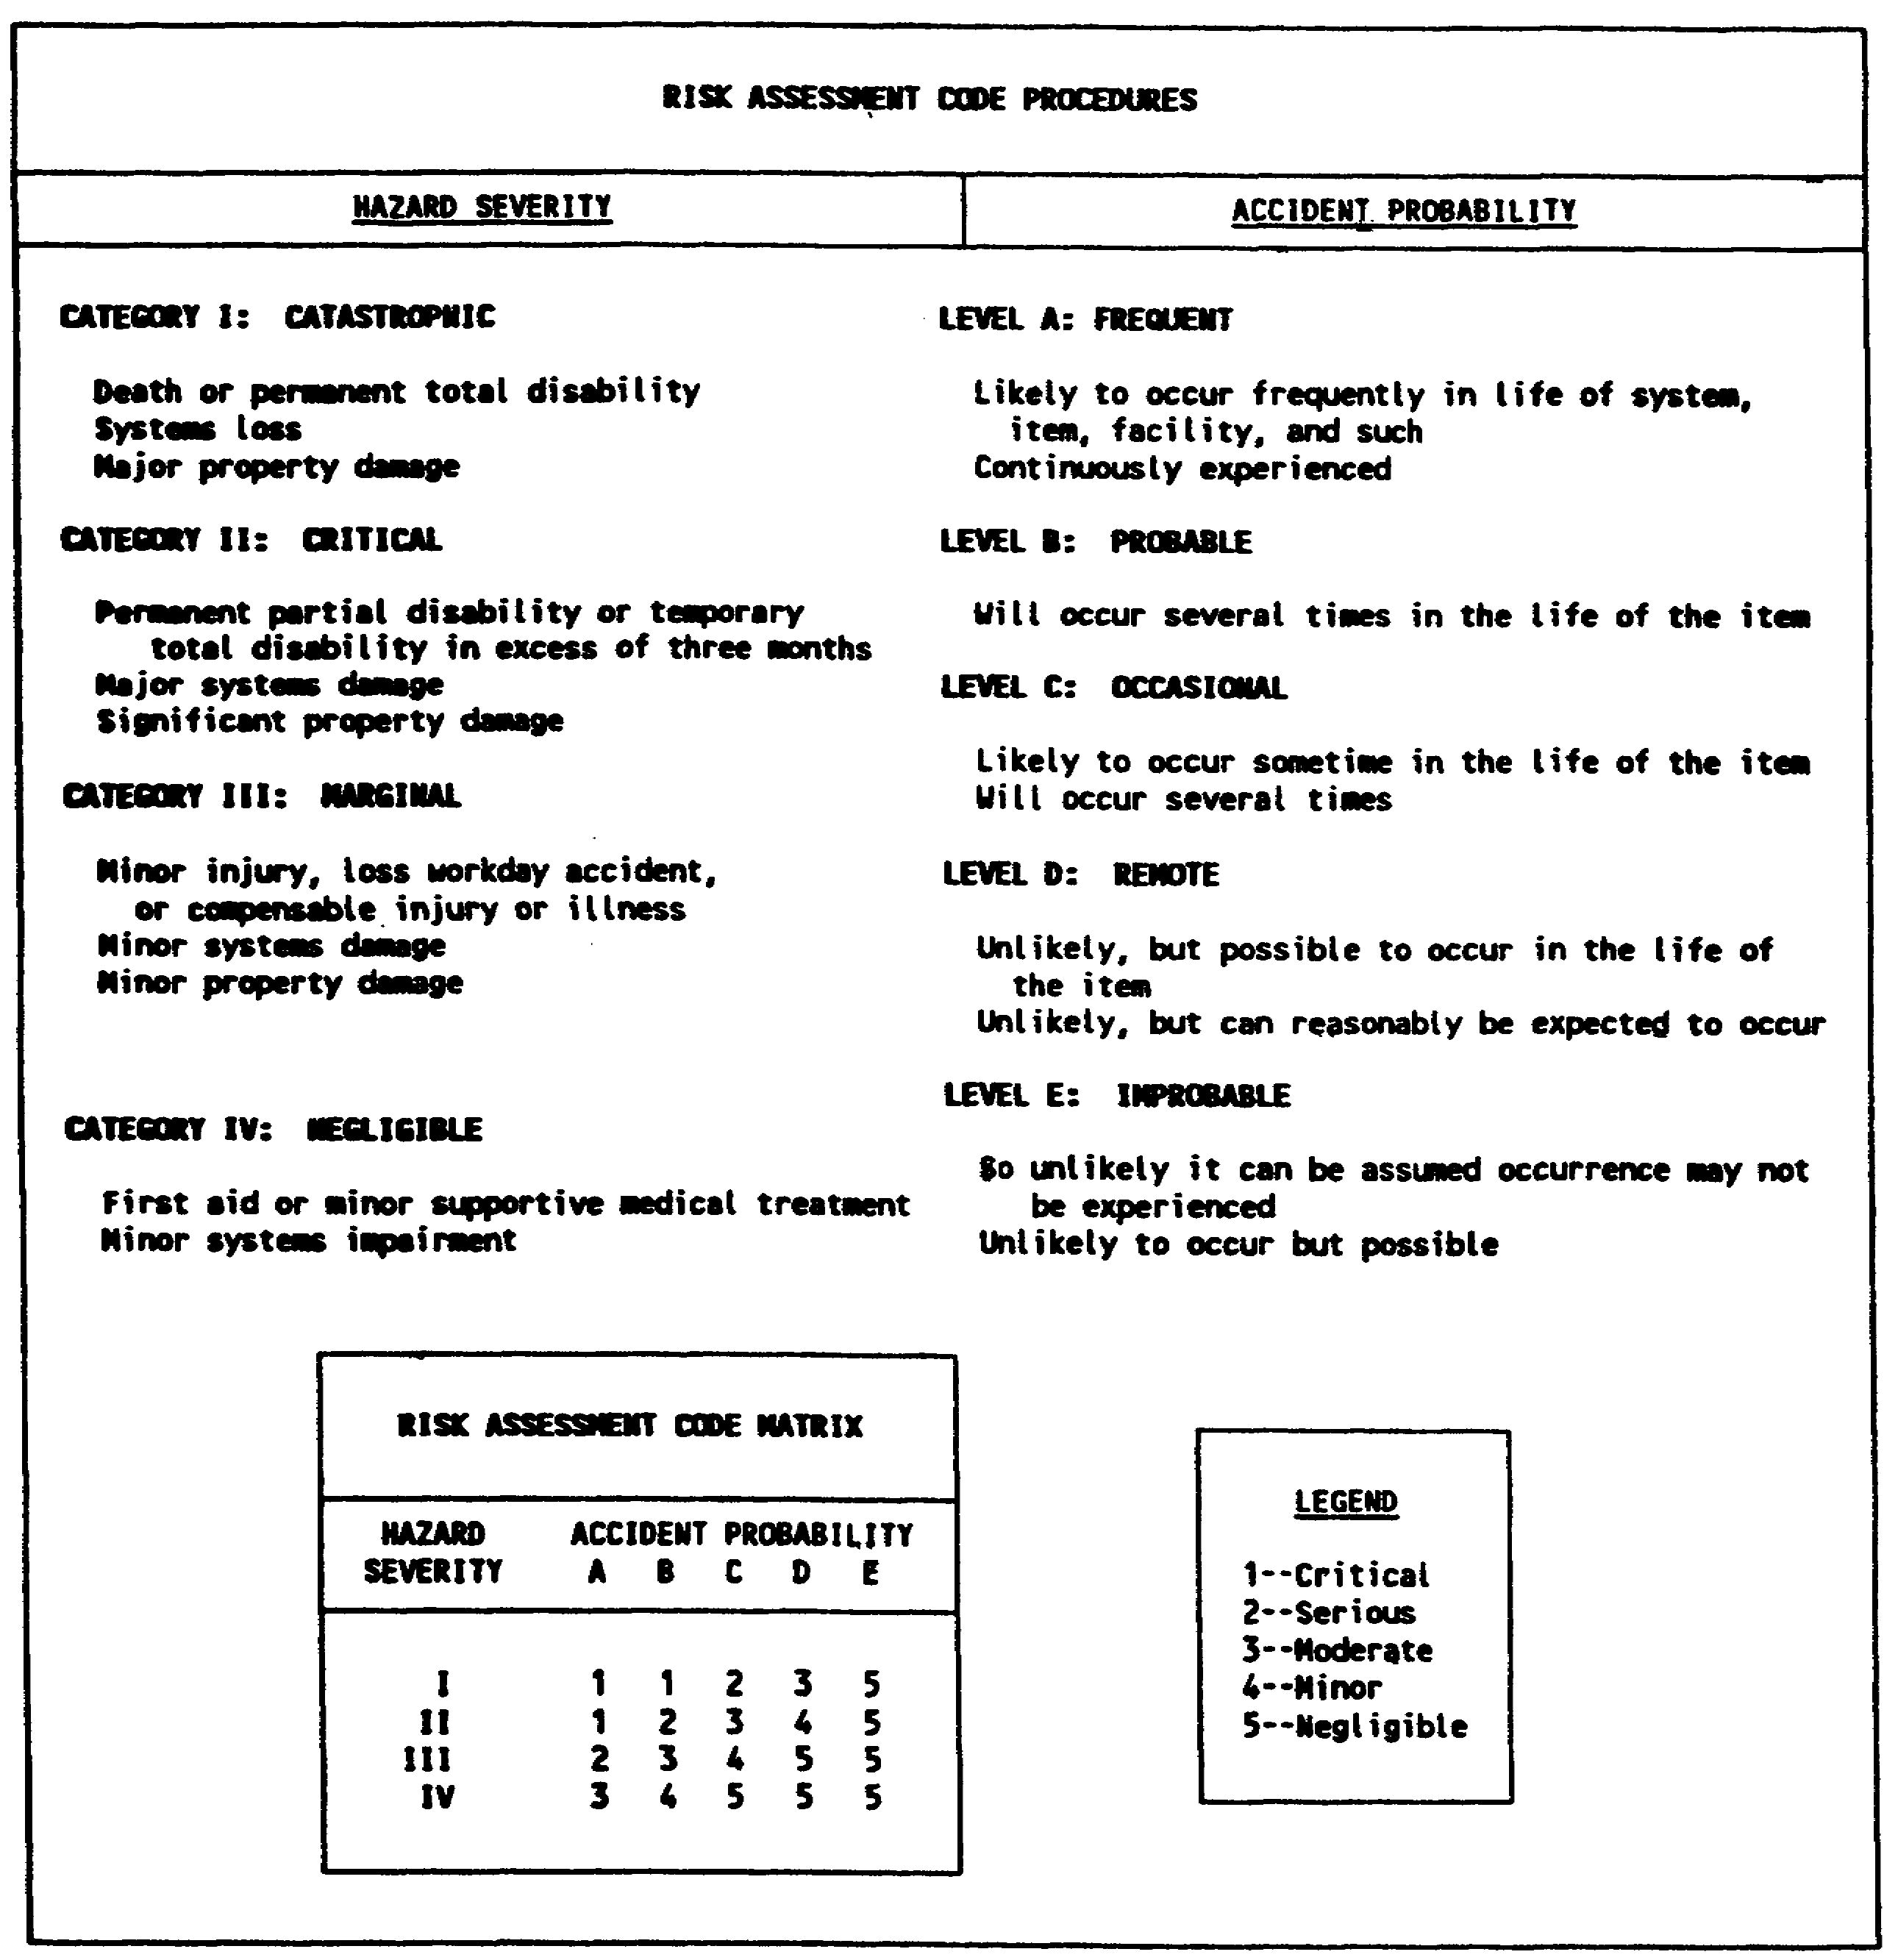

(4) Safety Attitudes

Attitude is the least understood and most difficult safety problem. An attitude is simply defined as the way a person feels about something. In this sense, attitudes are caught, not taught. All the knowledge in the world does not assure a favorable attitude. Certain needs must be fulfilled before favorable attitudes will develop.

2-9 AV0568
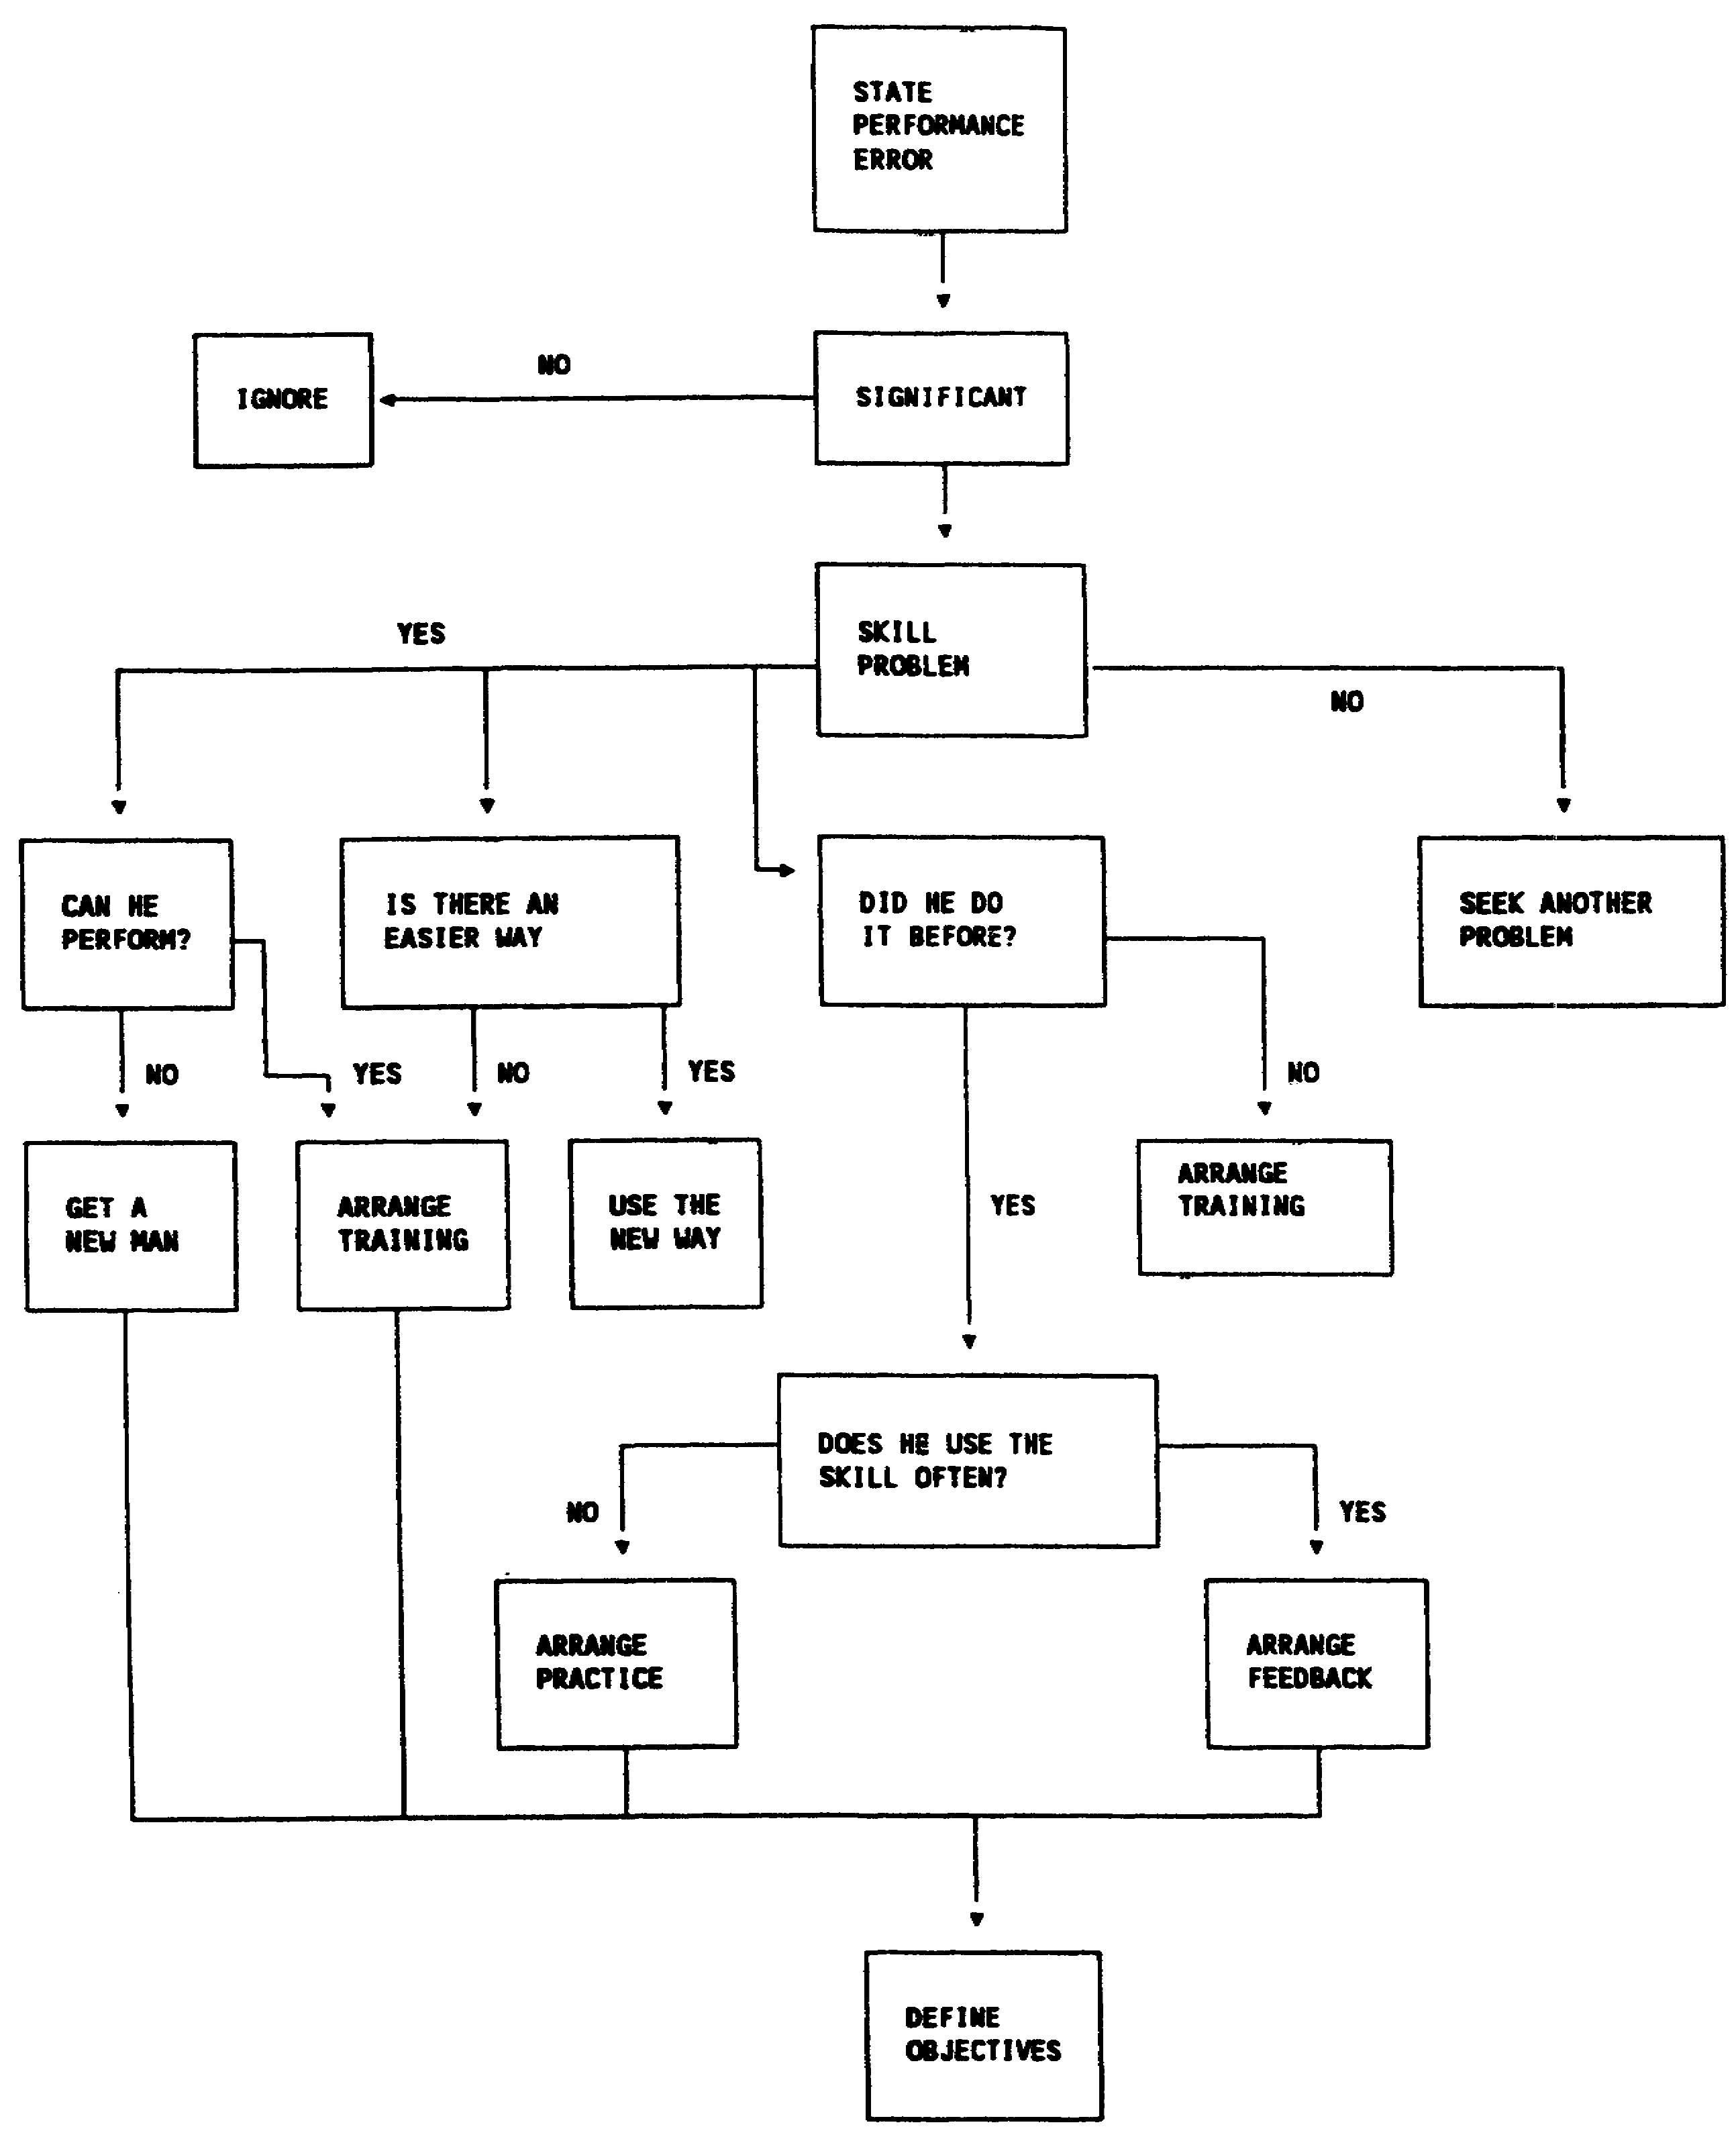

Figure 2-4. Systematic procedures for determining if there is a training need

2-10 AV0568
(a) Belonging. A person who feels he is a participating member of the group will develop desirable attitudes toward the objectives of the group (in this case, safety).

(b) Security and trust. A person who feels secure and trusted by the group will strive to reach group-determined objectives.

(c) Self-esteem. People who feel they are respected by the group will go with group objectives. If commanders can meet these needs for each individual in his command, they are well on their way toward setting up high morale and safe performance among their personnel in their various jobs, operations, and activities, on and off duty. A positive attitude toward safety also will lead to greater acceptance of the safety knowledge and skills provided in training.

c. Enforcement and Motivation

If the individual knows the correct procedure but does not use it, the problem is not a skill deficiency. That does not make it less of a problem, though.

(1) Dan Petersen, in his book Safety Management, A Human Approach, presents the following premise: "The normal person works unsafely because it is normal and logical to work unsafely in the situation in which he finds himself." A human error accident is NOT usually the result of abnormal behavior. To prevent human error accidents, then, we must either change normal human behavior or change the situation. The supervisor is in the best position to change situations--group pressure situations, psychological situations, boredom situations, no involvement situations. Petersen continues his analysis by asking if the employee is "punished for performing safely." Is production the only evaluation criteria? Are there time constraints that prevent operation "by the book?" Are there uncertain standards, such as going by the book unless we're in a crunch? Is the employee "rewarded for not performing safely"? Unsafe acts have different results for management than for workers. The worker may be willing to take a chance on unsafe performance if there is some benefit to be gained by it (completes the job sooner, avoids extra effort, or has always done it that way). Management, dealing with the laws of many, recognizes that chance-taking will lead to statistically predictable injury. There is usually a good reason behind a safety rule, even if it is not readily apparent to the employee.

(2) If the rewards for safe performance aren't evident, the reinforced unsafe behavior will continue. Use of negative reinforcement (punishment) may have short-term effect. Positive reinforcement is more

2-11 AV0568
lasting and has several advantages. Some of the advantages of reinforcing safe acts are—

(a) Removing the unwanted side effects of discipline (avoidance, conflict).

(b) Increasing job satisfaction.

(c) Increasing the chance of safe behavior rather than temporarily reducing unsafe behavior.

(d) Changing the relationship from police officer to helpful resource.

(e) Focusing attention on the correct way.

(3) Several reinforcements that can be applied to strengthen safe behavior are—

(a) Increasing the ratio of recognition to discipline; consciously including recognition during observations.

(b) Separating safety from discipline.

(c) Increasing the ratio of good inspection writeups to bad inspection write-ups.

(d) Providing tangible recognition; making safety a part of performance evaluation.

(e) Placing increased emphasis on personal and job gains from working safely.

(f) Using individual and work group participation in developing recommended safe procedures.

4. IMPLEMENTATION

Who will do what by when? The best information collection, causation analysis, and development of countermeasures will not correct a safety problem if not effectively carried out. If the personnel who will be involved in the implementation have had input into the previous steps, resistance to implementation will be lessened. Implementation instructions should be in writing to leave no doubt as to who will do what by when.

a. Accountability

The key to effective line safety performance is accountability. Management procedures that fix accountability must include three

2-12 AV0568
steps: define the task, set measurable objective standards, and make it matter.

(1) Define the Task

Define the tasks to be performed and integrate those tasks into the job. If safety can be made a part of the job from the first day a person fills the job, then half the problem of motivation is solved. Most people want to do a good job. If they feel safety is a part of the job, they will want to do that part well too. If they feel safety is an extra duty dumped on them, they will pay little attention to it.

(2) Set Measurable Objective Standards

How is the commander to know if a person is doing a good job or a poor job in executing his or her assigned safety tasks? The only way to know is to have some measurable indicators of performance. There are many areas from which we can select these measurable standards. We can measure actual accident costs in either human or monetary terms. This may not be valid if the unit is not large enough to have a statistically valid accident experience. Using rates is unfair and meaningless. Use of preaccident indicators such as hazard surveys will usually provide a good measure on which to base accident prevention status. Formal and informal safety sampling techniques also are practical.

(3) Make it Matter

We can identify tasks, set goals for key personnel, and carefully measure how well each manager or staff officer accomplishes those tasks. It may all come to nothing, however, unless we can make it matter to key personnel whether they reach the goals or not. If people don't get something in return for working toward the goal, then chances are they won't put forth much effort. There are two basic ways to make people care. The first is to reward or punish key personnel as individuals. The second is to show them how achieving their safety goals will help them reach their mission goals. Better management will conserve resources and improve morale.

b. Role Perception

The success of a safety program will depend a great deal on how involved personnel perceive their roles in the accident prevention process. Writing a policy does not solve any problems of fuzzy role perception. As a safety officer, you must consider the following when implementing safety problem countermeasures:

2-13 AV0568
(1) Is the task integrated into the job? If not, you are viewed as just adding work or obstacles. (Define and integrate the task.)

(2) Is the policy subject to interpretation? Can the employee misinterpret, modify, misunderstand, pass the buck, do nothing, substitute an alternate order, or delay? (Set measurable objective standards.)

(3) Does the employee believe, from the leader's past action, that it is important? (Make it matter.)

5. CONTROL

a. The accident prevention process is not completed after implementation. In devising countermeasures, the desired results should be stated. The control step determines whether the actual results meet expectations. All too often solutions are thrown at problems, not rated for effectiveness. The control function consists of the following steps:

(1) Setting Measurable Standards at Key Points that Show our Progress Toward an Objective

This includes selected measurable standards for all blocks in the causation model, not just the results block. Check for proper implementation of countermeasures (system defects). Survey for reduction in operating error. Compare data for the expected reduction in mishaps.

(2) Taking Corrective Action to Eliminate Gaps in Performance. Discrepancies found during the control step are recycled into the next cycle's information collection step.

b. These measurable standards may seem excessively complex. The essence of management, however, can be found in the functions of planning (deciding what is to be done and how) and control (seeing that it is done).

2-14 AV0568
LESSON 2

PRACTICE EXERCISE

The following items will test your grasp of the lesson material. Each item has only one correct answer. When you complete the exercise, check your answers with the answer key that follows. If you answer any item incorrectly, restudy that part of the lesson.

1. The first step in the accident prevention process is

A. planning.
B. coordinating.
C. causation analysis.
D. information collection.

2. The three traditional avenues of accident prevention countermeasures are engineering and design, education and training, and

A. skills and knowledge.
B. persuasion and posters.
C. enforcement and motivation.
D. estimation of effectiveness.

3. To effectively fix accountability for safety performance, management must define the task, establish measurable objective standards, and

A. expect results.
B. make it matter.
C. implement instructions.
D. make exceptions to the rules.

4. Using positive reinforcement techniques

A. decreases job satisfaction.
B. is unacceptable in the Army.
C. focuses attention on the correct way.
D. decreases probability of safe behavior.

5. The control step determines whether the actual results meet expectations.

A. true
B. false

2-15 AV0568
6. Implementation instructions should be general in nature.

A. true
B. false

7. Accident reports provide the only data needed for the accident prevention to be effective.

A. true
B. false

8. In devising countermeasures, cost must be considered.

A. true
B. false

9. Countermeasures should be targeted on the system defect.

A. true
B. false

10. System defects are the cause of operating errors.

A. true
B. false

2-16 AV0568
LESSON 2

PRACTICE EXERCISE

ANSWER KEY AND FEEDBACK

Item Correct Answer and Feedback

1. D. information collection.

Information should be collected from all aspects of the causation model sequence. Causation analysis, countermeasure development, horizontal implementation, and control procedures then should be performed by the safety officer. (page 2-2, Figure 2-1)

2. C. enforcement and motivation.

Self-explanatory. (page 2-6, para 3)

3. B. make it matter.

The key to effective line safety performance is accountability. Make safety a part of all tasks to perform. Use surveys to define standards and motivate personnel to take a personal interest in safety. (page 2-12, para 4a)

4. C. focuses attention on the correct way.

By focusing attention on the correct way to perform a task, you are emphasizing that safely performing to standard is more important than getting the job done by cutting corners. (page 2-12, para 3c(2)(e))

5. A. true

The control step indicates whether the countermeasure to the problem actually solved the system defect or simply papered over it. (page 2-14, para 5)

2-17 AV0568
6. B. false

Implementation instructions should be in writing to leave no doubt as to who will do what by when. (page 2-12, para 4)

7. B. false

Accident reports are only one of many sources of information that should be used by the safety officer when developing an effective accident prevention program. Other information sources include inspections, surveys, and operational hazard reports (OHRs). (page 2-3, para 1b)

8. A. true

Cost should be considered as a factor in selecting a course of action but should not prevent a countermeasure from being developed. If a most cost effective system can be developed that results in the same solution and duration of effectiveness, it should certainly be given more weight. (page 2-6, para 3)

9. A. true

Countermeasures should be targeted on the system defect through a redesign of one or more of the elements of the system: task, training, person, environment, and material. System defects are the cause of operating errors and are the most cost effective to fix. (page 2-6, para 3)

10. A. true

An operating error is the act of performing an unsafe action. A system defect is the cause of the error through allowing the act to happen, or not identifying the act as unsafe. (page 2-4, para 2b)

2-18 AV0568
LESSON 3

RESPONSIBILITIES AND DUTIES

Critical Task:

OVERVIEW

LESSON DESCRIPTION:

This lesson will help you become familiar with command and individual responsibilities and duties toward safety.

TERMINAL LEARNING OBJECTIVE:

ACTION: You will become familiar with command and individual responsibilities and duties toward safety.

CONDITION: You will use the lesson text to complete the action.

STANDARD: You will become familiar with command and individual responsibilities and duties toward safety according to this lesson.

REFERENCE: The material in this lesson was derived from the following publication: AR 385-95 and DA Pamphlet 385-95.

INTRODUCTION

Although commanders and their supervisory personnel are responsible for conducting a vigorous effort to prevent accidents in all operations and activities, each also is responsible for safety. Aviation accident prevention is the responsibility of all personnel--commanders, supervisors, and individuals. This lesson will outline specific roles of commanders, their staffs, and individuals in the aviation accident prevention effort.

1. COMMANDER’S RESPONSIBILITY

Commanders will integrate accident prevention awareness into all functional areas involving the use, operation, and maintenance of aircraft. To help in fulfilling this responsibility, aviation accident prevention directives will be published to provide adequate instructions

3-1 AV0568
and safeguards for protecting personnel and equipment without reducing mission effectiveness. Specifically, commanders will assure that—

a. Accident prevention directives include all aviation operations down through small unit and detachment levels.

b. Specific aviation accident prevention and safety responsibilities are delegated to applicable staff members and first-line supervisors.

c. An SOP is prepared for all aviation operations within the command listed in AR 385-95, para 1-6a(4).

d. The need to follow sound principles and safety practices during all aviation operations, regardless of mission urgency, is emphasized.

e. All personnel are aware of and follow unit SOPs.

f. A positive plan is developed so mission and aircraft assignments are within aircrews' current capabilities and qualifications.

g. A firm standardization and training program is set up to achieve the flight proficiency standards.

h. Approved recommendations of aircraft accident investigation boards are carried out promptly.

i. The Director of Army Safety, via the US Army Safety Center, is informed promptly of problems on the prevention of aviation accidents.

j. Aviation safety officer (ASO) has direct access to the commander on all aviation accident prevention matters.

k. Aviation accident prevention plans are continuously reviewed for effectiveness. Commanders will—

(1) Assure (by inquiry, discussion, command emphasis, and interest) that unit personnel know that they support the aviation accident prevention plan and personally monitor all the activities.

(2) Set up a safety council and attend council meetings.

(3) Attend safety briefings.

(4) Request quotas for safety schools conducted by the US Government and contractors, send qualified personnel to attend

3-2 AV0568
these courses, and place school-trained safety personnel in proper positions.

2. STAFF RESPONSIBILITY

a. Command Safety Director (Installation and Major Command Level)

The command safety director is responsible for overall safety management within the command. This includes providing for safety training, safety education and promotion, accident reporting, analysis, and statistics. The safety director also will integrate safety into all activities within the command.

b. Aviation Safety Officer and Flight Safety Technician

The ASO, working with the command safety director and staff aviation officer, advises the commander on all aviation safety matters' ASO duties are listed in Figure 3-1.

c. Army Aviator

The Army aviator is the basic element in the command line of aircraft accident prevention. Aviation duties are listed in Figure 3-2.

d. Aviation Maintenance Officer

The aviation maintenance officer will assure that an effective preventive maintenance program is developed and kept. Responsibilities and duties include the list in Figure 3-3.

e. Flight Surgeon

The flight surgeon helps and advises the command in all aviation medicine matters. The flight surgeon will perform the duties listed in Figure 3-4.

f. Aviation Safety Noncommissioned officer

The aviation safety NCO aids, advises, and makes recommendations to the ASO on aviation accident prevention matters. Aviation safety NCO duties are listed in Figure 3-5.

3. INDIVIDUAL RESPONSIBILITY

a. The Supervisor

Anyone with permanent or temporary authority over another person is a supervisor. All military and civilian supervisory personnel should help the commander in the accident prevention

3-3 AV0568
program by intelligently promoting adherence to set up safety procedures.

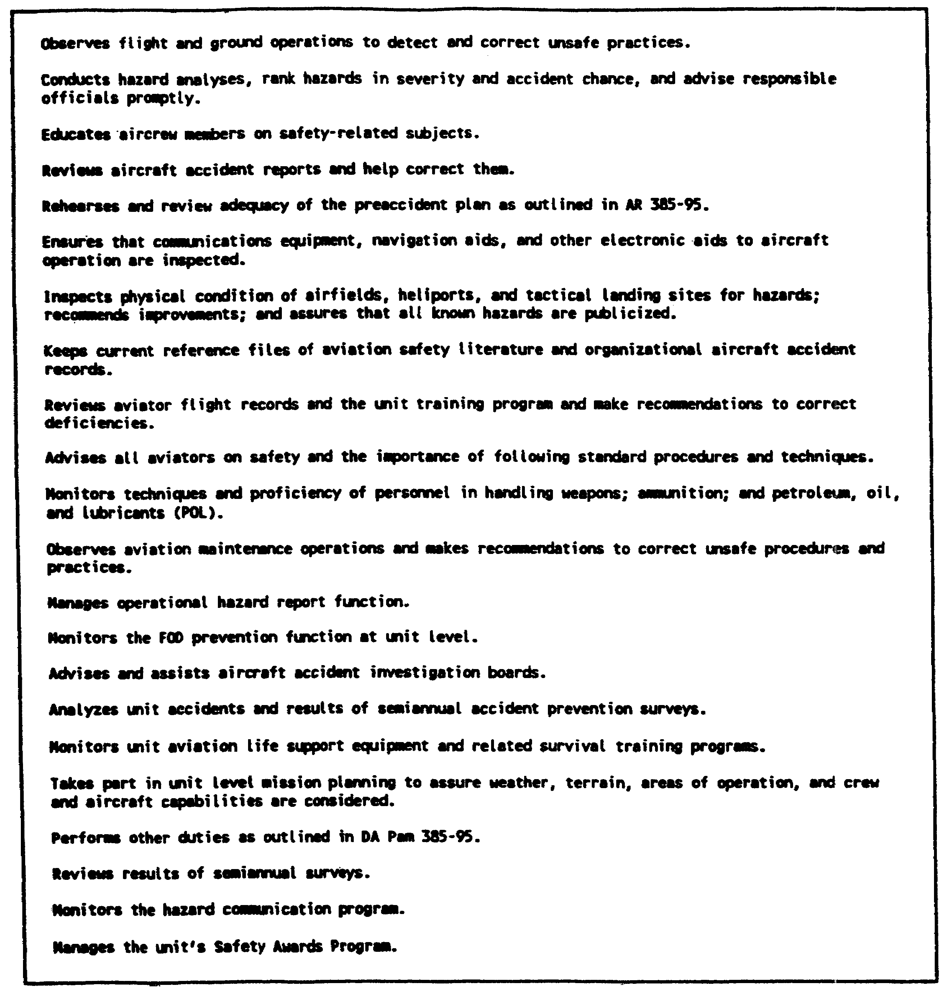

Figure 3-1. Aviation safety officer duties

3-4 AV0568
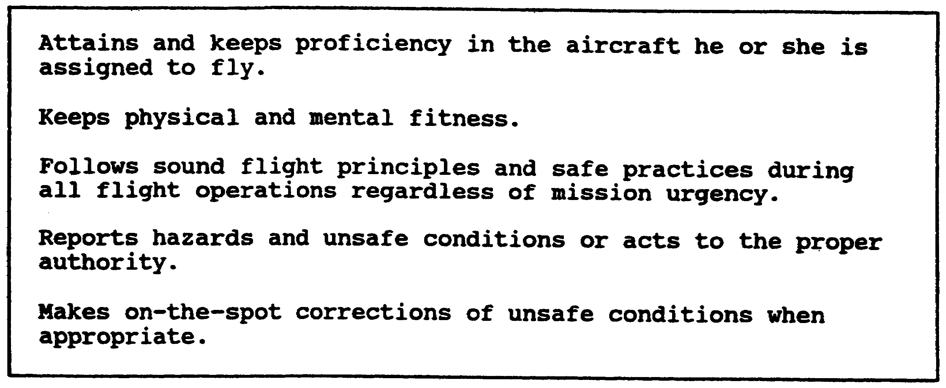

Figure 3-2. Army aviator duties

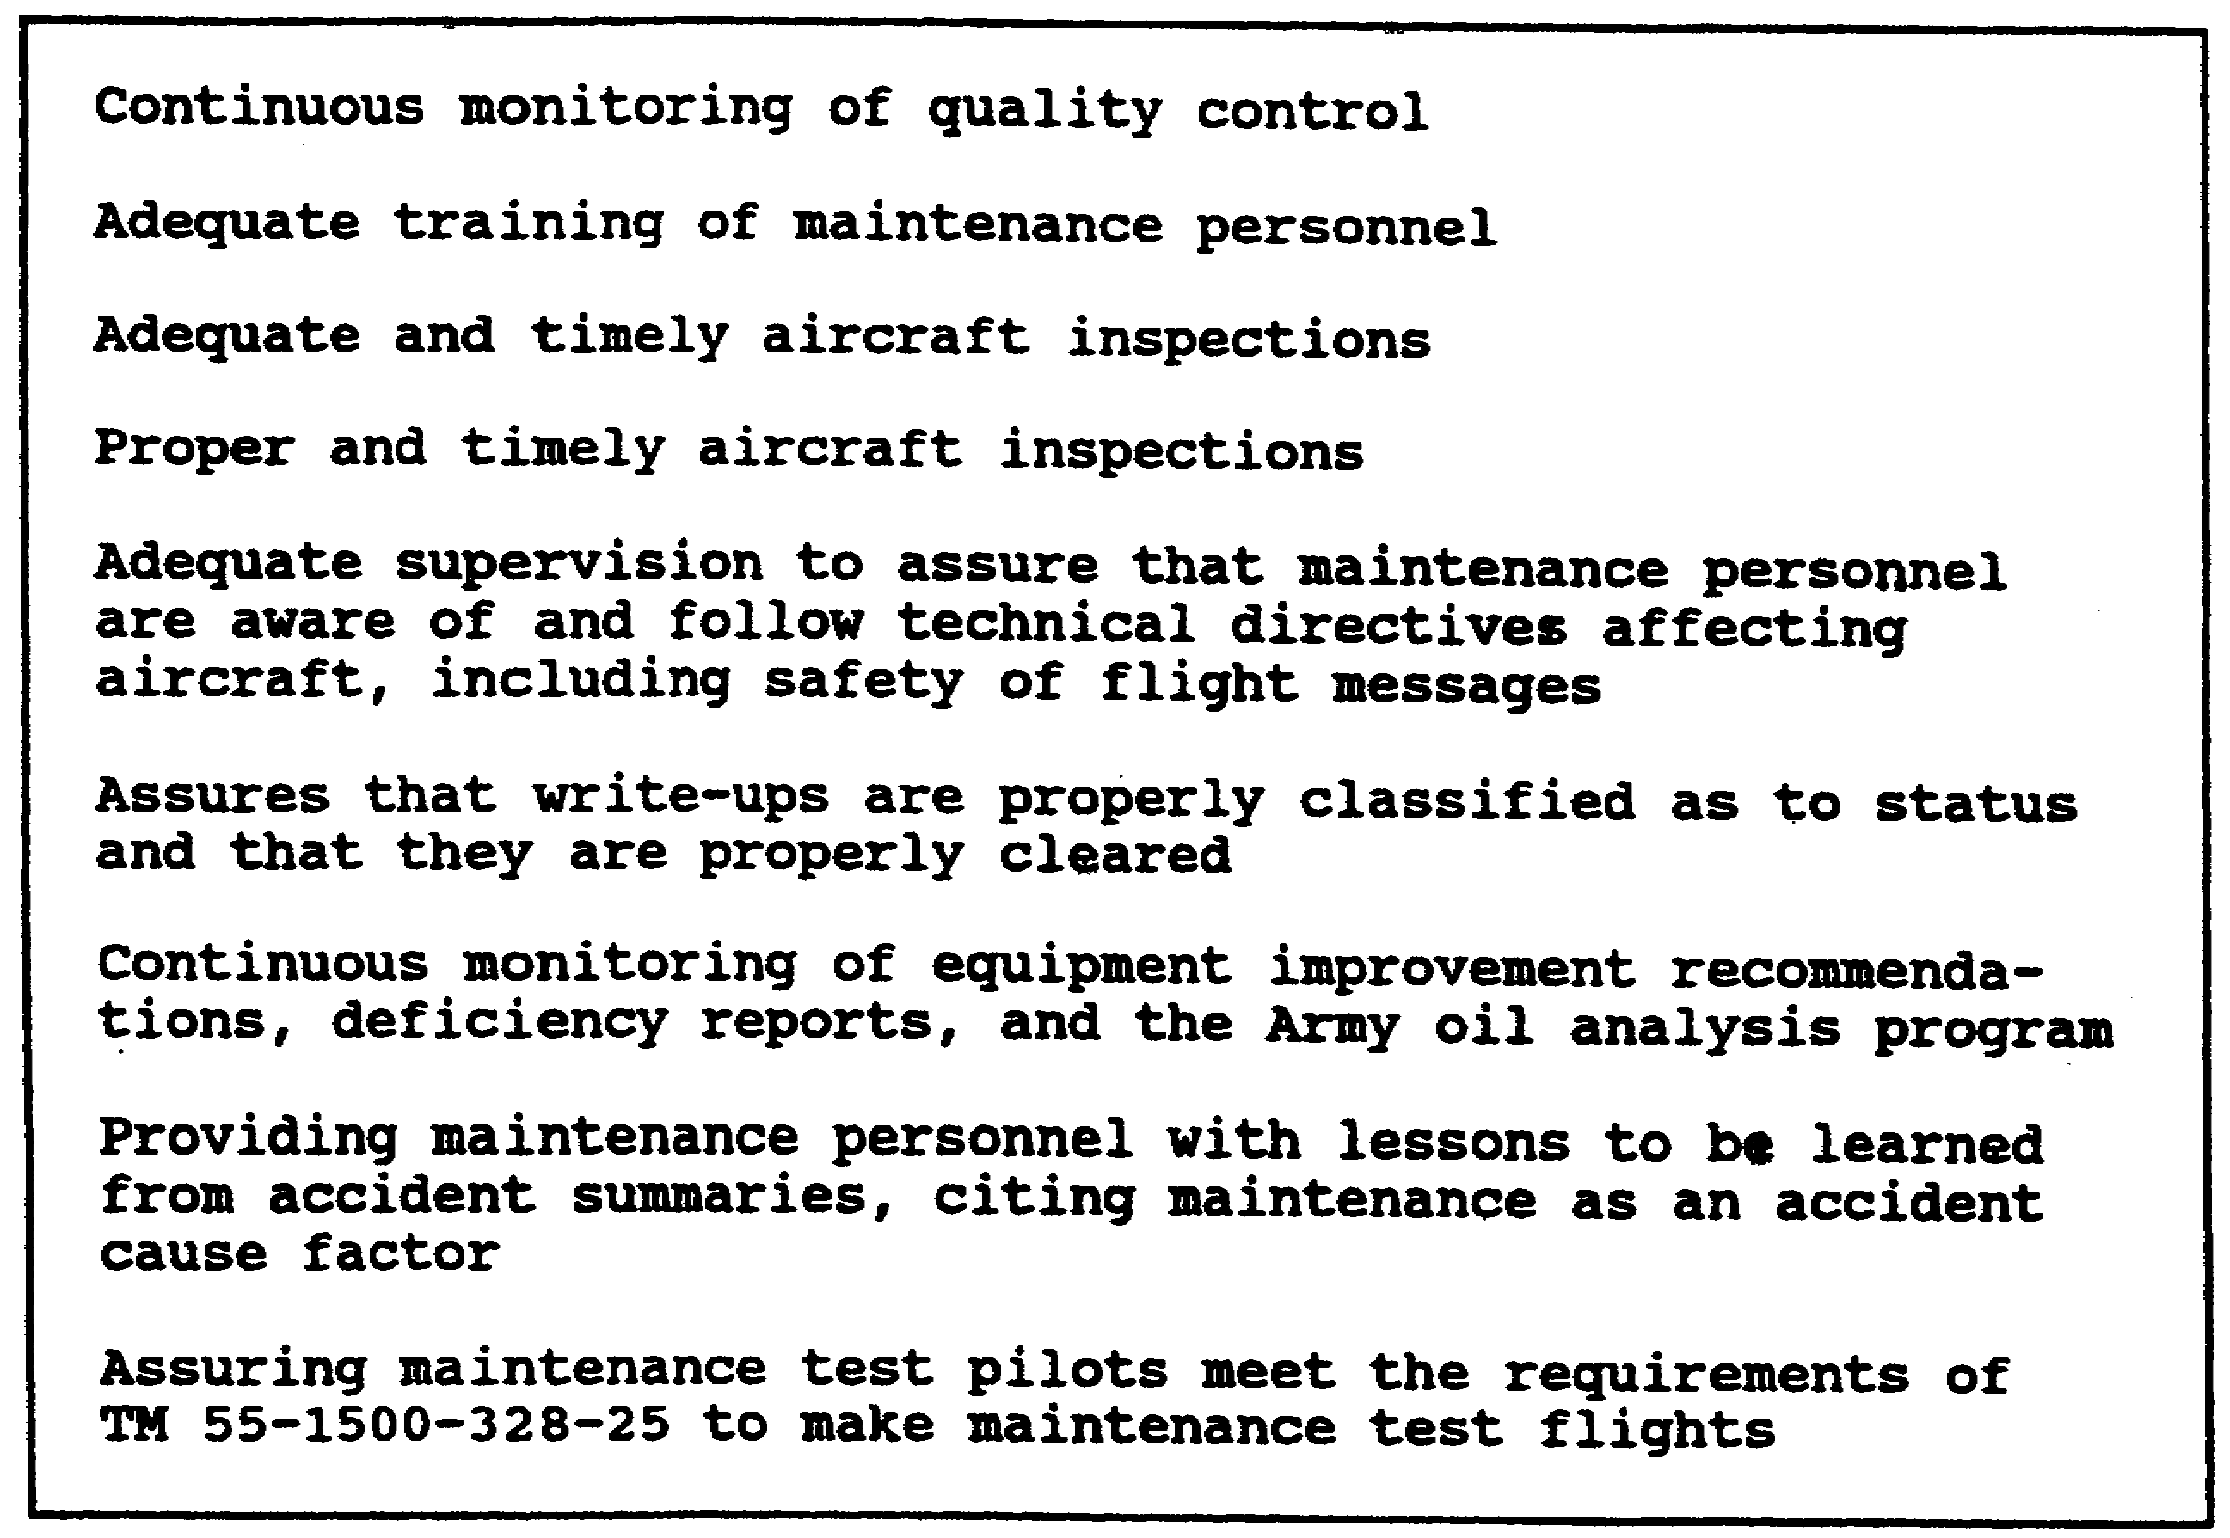

Figure 3-3. Aviation maintenance officer duties

3-5 AV0568
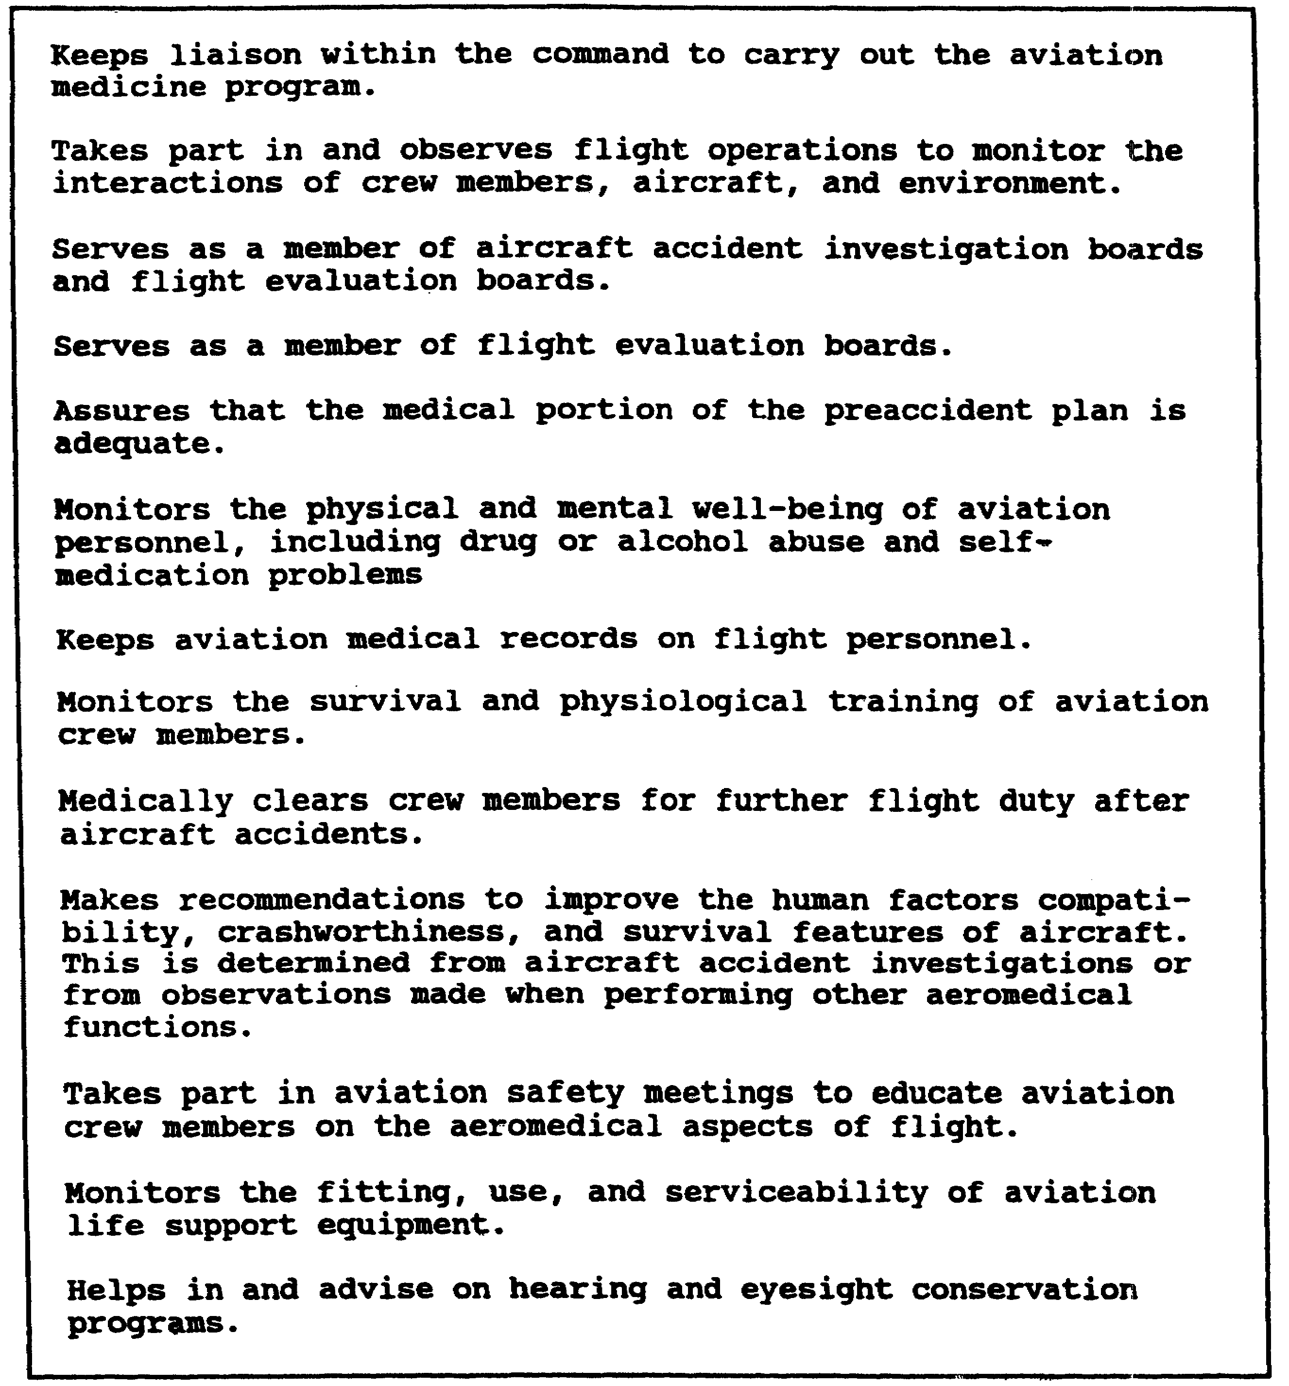

Figure 3-4. Flight surgeon duties

(1) Safety Supervision

The qualities necessary for effective supervision are the same in safety as in any other endeavor. Effective supervision is

3-6 AV0568
associated with leadership. Leadership that enlists the cooperation and support of the group works best. The supervisor must show the importance of safety through his or her own actions. As a leader, the supervisor cannot personally ignore safety regulations and expect others to follow them.

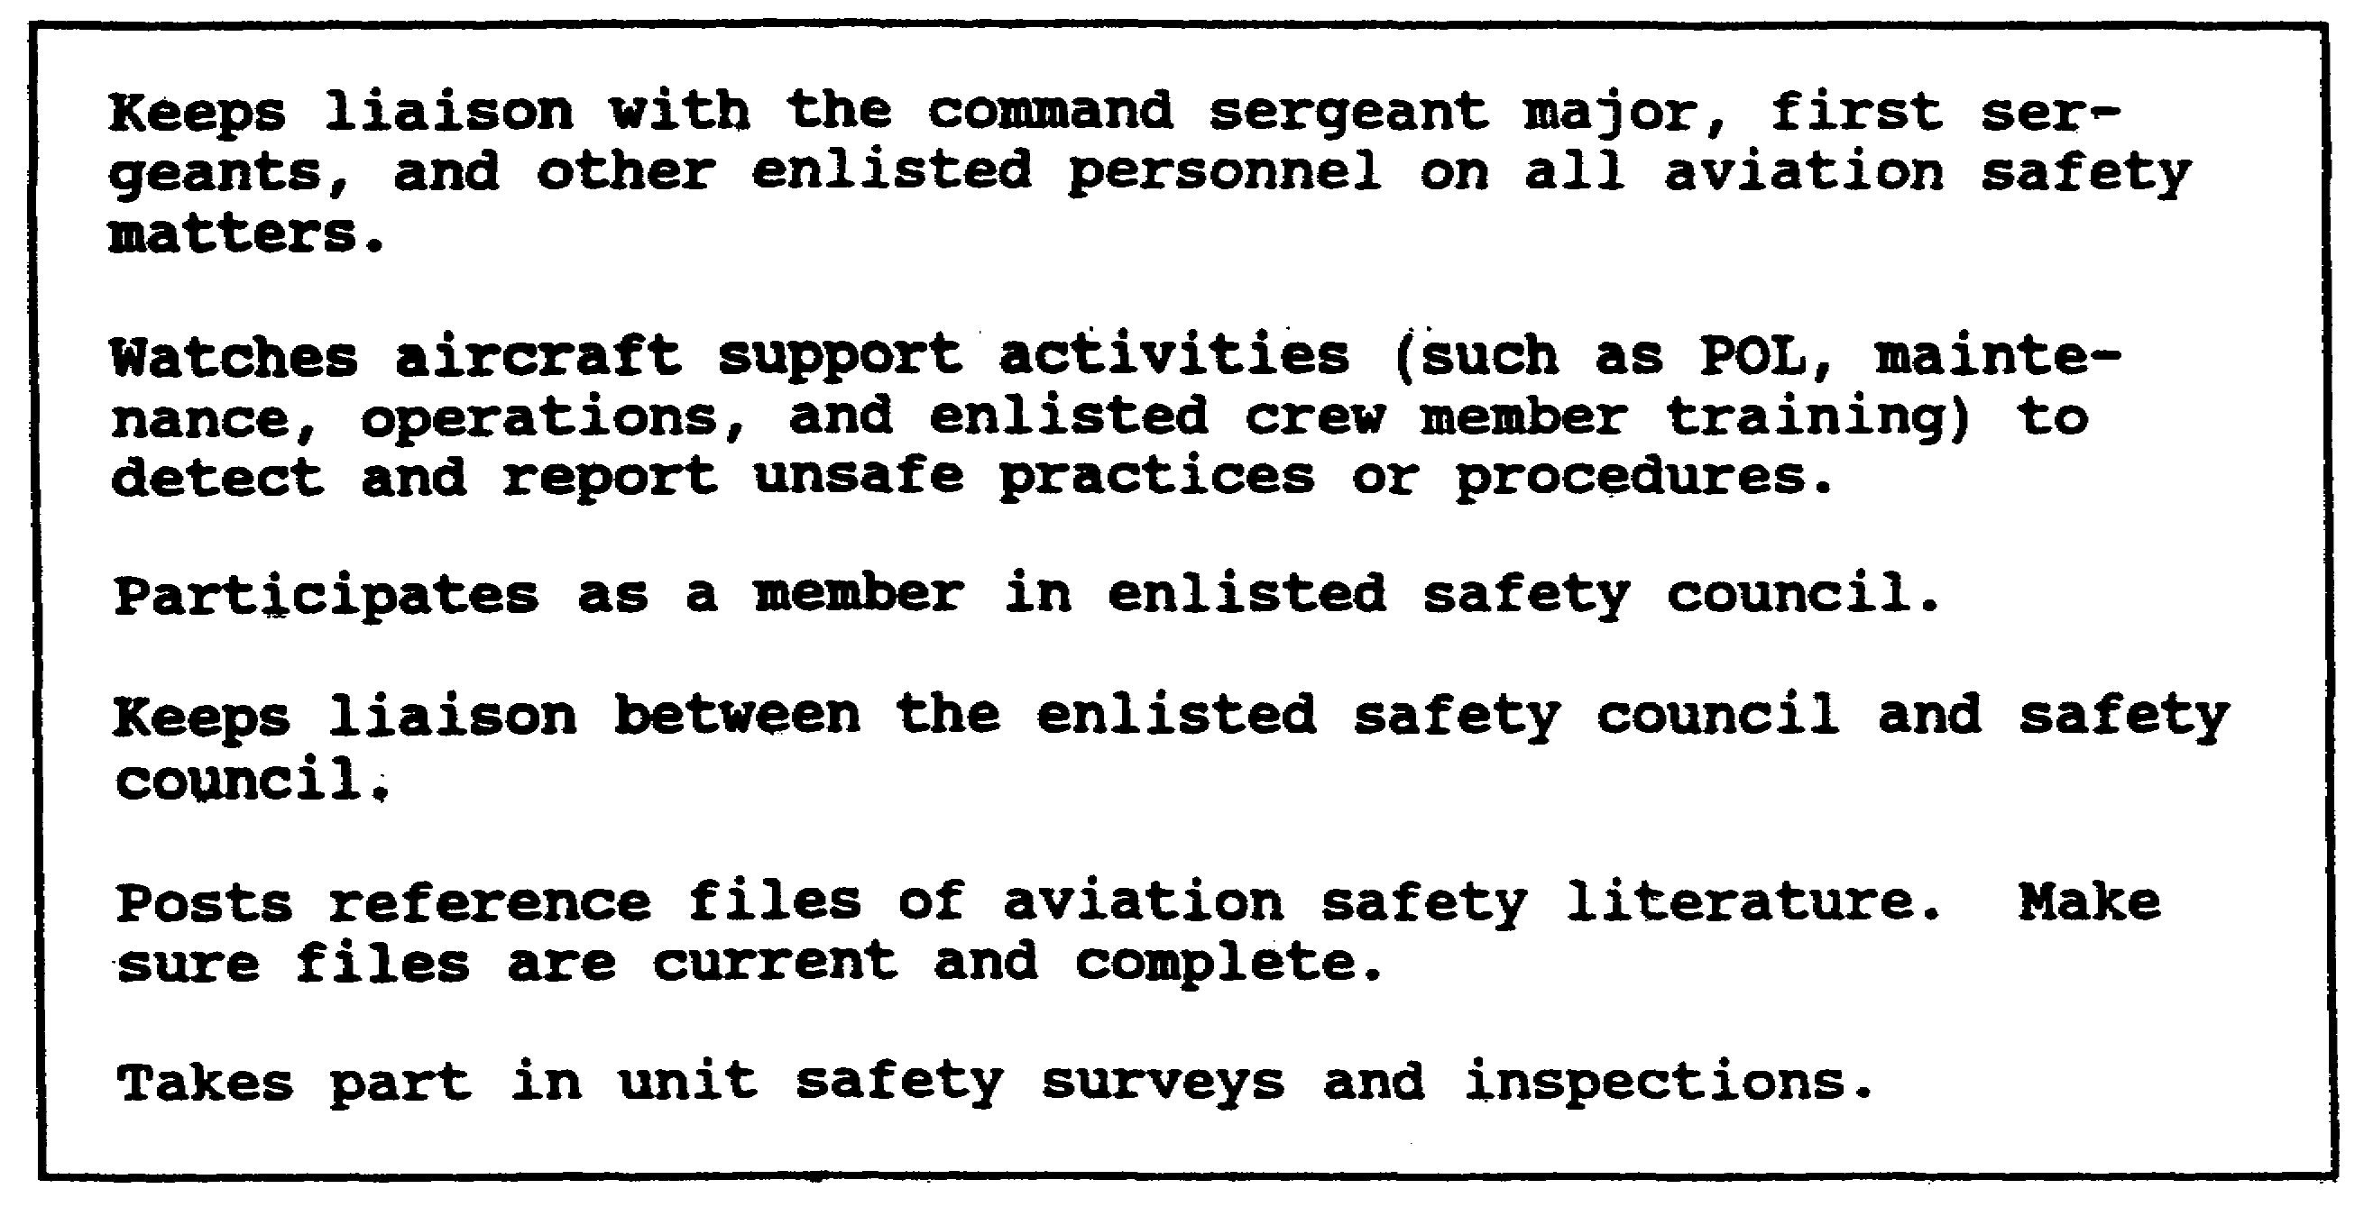

Figure 3-5. Aviation safety noncommissioned officer duties

(a) It is extremely important that people understand safety rules and the need for them. Blind obedience is not enough.. No supervisor can keep a close watch on ALL assigned personnel ALL the time. If people understand why they should perform their work in a certain way, they are more likely to perform safely though the supervisor is not looking over their shoulders.

(b) A group that works with rather than for its supervisor is more effective in its performance. A supervisor must exercise authority fairly. If personnel think their supervisor exercises his or her authority in unpredictable and unfavorable ways, they may vie with each other to keep the supervisor's favor. This can lead to hostility that destroys the cooperation needed for effective (safe) group performance. Accident rates are lower under supervisors with superior leadership ability.

(2) Basic Ingredients for Safety Supervision

Research has proven that unfamiliarity with a task (little prior training or experience) and isolation (performing a task while

3-7 AV0568
alone) are two factors associated with accidents. good supervision can prevent these circumstances from arising and, thus, prevent accidents. To keep safe performance among personnel, a supervisor must—

(a) Train personnel to perform safely.

(b) Develop safe methods of performing tasks.

(c) Promote teamwork among assigned personnel.

(d) Motivate assigned personnel to perform safely.

(e) Be able to safely perform and set up each task.

(f) Explain safety rules and emphasize the need for them.

(g) Properly place people in tasks within their abilities.

(h) Make available and keep tools and equipment in safe condition.

(3) Supervisory Responsibilities

All supervisory personnel help the commander in the unit accident prevention program by requiring intelligent adherence to set up safe operating procedures. Supervisors orient new personnel, teach safe practices, enforce rules, investigate accidents, prepare and submit accident reports, and conduct safety inspections and safety meetings as required. No one is better qualified or in a more strategic position to discover and correct safety hazards than the supervisor of an activity. Supervisors deal directly with the worker and the job. They are in the best position to improve the worker's attitudes toward the job, knowledge of the job, and skill. They also are in the best position to insist on safe practices on the job and correct unsafe conditions involved in the job. When supervisors fail in any of these responsibilities, inefficient and costly results can be expected. Supervision is a method of preventing accidents through continuous instruction and guidance, official persuasion, and recourse to enforcement when necessary. Supervision is a basic accident prevention control, functioning on the principles that individual observance of safety standards can be assured if necessary guidance, proper training, and development of good work habits are provided and that individual competency will be assured regardless of whether or not supervisors are in the area. When supervision fails in this accomplishment, constant observation and frequent enforcement become necessary.

3-8 AV0568
b. The Individual

Each military and civilian employee is responsible for accident prevention while on and off duty. Each must obey rules and SOP, correct or report unsafe conditions, report all accidents, use protective devices, and as appropriate, warn others of known hazards if they fail to observe safety regulations. Individuals make their greatest contribution to their units' safety program when they develop safety awareness in every activity in which they engage, on and off duty.

3-9 AV0568
LESSON 3

PRACTICE EXERCISE

The following items will test your grasp of the lesson material. Each item has only one correct answer. When you complete the exercise, check your answers with the answer key that follows. If you answer any item incorrectly, restudy that part of the lesson.

1. No one is better qualified or in a more strategic position to discover and correct safety hazards than the supervisor.

A. true
B. false

2. The Army aviator is the basic element in the command line of aircraft accident prevention.

A. true
B. false

3. Commanders will assure that complete and clearly defined SOPs are prepared for all aspects of aviation operations.

A. true
B. false

4. Individuals have no responsibility for safety because it is a command responsibility.

A. true
B. false

5. The aviation safety officer advises the commander in all matters on aviation safety.

A. true
B. false

6. The command safety director is responsible for overall safety management.

A. true
B. false

3-11 AV0568
7. Two factors associated with accidents are unfamiliarity with the task and isolation.

A. true
B. false

8. The aviation safety officer observes flight and ground operations to detect and correct unsafe practices.

A. true
B. false

9. Accident prevention directives will include all aviation operations down through small unit and detachment level.

A. true
B. false

10. Safety is an entity that will not be integrated into all functional areas.

A. true
B. false

3-12 AV0568
LESSON 3

PRACTICE EXERCISE

ANSWER KEY AND FEEDBACK

Item Correct Answer and Feedback

1. A. true

Supervisors are the people who design and operate systems. Supervisors train the operators in the performance of tasks, establish the measurable standards to which the task must be done safely, and motivate subordinates to take a personal interest in safety. (page 3-9, para 3a(3))

2. A. true

The aviator flies the aircraft and must be fully proficient in its use and operation. It is not until the aircraft moves that it is usually a potential safety hazard. (page 3-4, para 2c)

3. A. true

Commanders are responsible for conducting a vigorous effort to prevent accidents in all operations and activities involving aviation activities that include developing an SOP, (page 3-2, para 1c)

4. B. false

Each military and civilian employee is responsible for accident prevention while on and off duty. (page 3-10, para 3b)

5. A. true

The aviation safety officer, working with the command safety director and staff aviation officer, advises the commander on all aviation safety matters. (page 3-4, para 2b)

6. A. true

The command safety director is responsible for overall safety management within the command. (page 3-4, para 2a)

3-13 AV0568
7. A. true

Research has proven that little prior training or experience and performing a task while alone are two factors associated with accidents. A combination of these two elements is a potential safety problem. (page 3-8, para 3a(2))

8. A. true

The aviation safety officer and everyone else who works in or around aircraft is responsible for observing flight and ground operations to detect and correct unsafe practices. (page 3-5, Figure 3-2)

9. A. true

Commanders will integrate accident prevention awareness into all functional areas involving the use, operation, and maintenance of aircraft down through small unit and detachment level. (page 3-2, para 1a)

10. B. false

Not only will safety be integrated into all functional areas, but at Installation and Major Command Levels, a director will be appointed with this primary responsibility. (page 3-4, para 2a)

3-14 AV0568
LESSON 4

AIRCRAFT ACCIDENT PREVENTION SURVEY

Critical Task:

OVERVIEW

LESSON DESCRIPTION:

This lesson will familiarize you with the contents of the Guide to Aviation Resources Management for Aircraft Mishap Prevention prepared by the United States Army Aviation Branch Safety Office (ABSO), US Army Aviation Center, and how it is used when conducting an aircraft accident prevention survey.

TERMINAL LEARNING OBJECTIVE:

ACTION: You will become familiar with the contents of the ABSO Guide to Aviation Resources Management for Aircraft Mishap Prevention prepared by the United States Army ABSO, USASC, and how it is used when conducting the aircraft accident prevention survey.

CONDITION: You will use the lesson text to complete the action.

STANDARD: You will become familiar with the contents of the ABSO Guide to Aviation Resources Management for Aircraft Mishap Prevention and how to use it as an aid when conducting an aircraft accident prevention survey according to this lesson.

REFERENCE: The material in this lesson was derived from the following publication: AR 385-95 and the ABSO Guide to Aviation Resource Management for Aircraft Mishap Prevention.

INTRODUCTION

AR 385-95 directs implementation of the aircraft accident prevention survey. This survey isolate potential aviation hazards in facilities, equipment, and personnel. Commanders through their staff, must be kept informed of the progress of the unit's accident prevention effort. The aircraft accident prevention survey is one of the best methods for monitoring a unit's safety effort. The aircraft accident prevention

4-1 AV0568
survey is not intended as a cure-all for aviation unit commanders' accident woes and weak spots.

1. THE SURVEY

a. Although an accident prevention survey must consider all functions that directly or indirectly affect operations, breaking it down so each function is reviewed separately will help in evaluating of a unit's operations. To be effective, an aviation accident prevention survey should be a revolving project. Those conducting the survey should be thoroughly familiar with staff members of the proper agency. One survey would show only the potential problem areas of the moment and would not provide any assurance that corrective action would be taken. Follow-up surveys assure that corrective action was taken on recommendations made after a previous survey. They also assure that no new potential problem areas have developed since the last survey or that potential problem areas that were overlooked before or considered unimportant at the time are brought into proper perspective.

b. AR 385-95 states that, as a minimum, surveys will be made semiannually. Just how detailed and how often the survey should be made will vary in individual cases. Answers to these questions will be regulated by the effectiveness of a particular accident prevention program. A commander may decide that a particular phase should be made more often than others. Another commander will find that many items do not apply to his or her unit.

EXAMPLE: The section on instrument approaches when the commander has no instrument approaches available.

2. AVIATION BRANCH SAFETY OFFICE, US ARMY AVIATION CENTER

a. The ABSO booklet, Guide to Aviation Resources Management for Aircraft Mishap Prevention, contains basic checklists for most aviation unit functions. These checklists should be expanded or changed to suit the particular aviation unit. Checklists should be furnished to branch chiefs so they fully understand what is expected of them. The booklet prepared by the ABSO contains these checklists. The foreword and instructions on how to use this guide are located just inside the front cover.

NOTE: The question-and-answer checklist is meant merely to serve as a guide for commanders and to instill an awareness of potential problem areas within their units.

b. Although most of the items found on the checklists are self-explanatory, a few comments are warranted.

4-2 AV0568
(1) Section 1, Operational Analysis

Check previous surveys for discrepancies and corrective actions. If few or no operational hazard reports have been recorded, encourage personnel to submit them.

(2) Section 2, Aviation Management

The SOP will be posted where it will be available for all personnel to read. As a safety officer, you must question personnel to find out if they are aware of the commander's safety policies. Safety posters may be obtained by writing to Commander, United States Army Safety Center, ATTN: CSSC-IM, Fort Rucker, AL 36362-5363, or by calling DSN 558-2062/4806 or commercial (205) 255-2062/4806. If you have access to the Federal Telecommunication system (FTS), the Fort Rucker FTS number to call is 539-2062/4806.

4-3 AV0568
LESSON 4

PRACTICE EXERCISE

The following items will test your grasp of the lesson material. Each item has only one correct answer. When you complete the exercise, check your answers with the answer key that follows. If you answer any item incorrectly, restudy that part of the lesson.

1. The aircraft accident prevention survey, if properly used, will solve all aviation problems.

A. true
B. false

2. To be effective, the aircraft accident prevention survey should be conducted monthly.

A. true
B. false

3. Just how detailed the survey should be will vary from unit to unit.

A. true
B. false

4. One purpose of the aircraft accident prevention survey is to make the commander aware of potential problem areas.

A. true
B. false

5. The Guide to Aviation Resources Management for Aircraft Mishap Prevention prepared by ABSO should not be changed without written approval from originator.

A. true
B. false

6. Follow-up surveys should be made to assure that corrective action was taken on recommendations made after previous surveys.

A. true
B. false

4-5 AV0568
LESSON 4

PRACTICE EXERCISE

ANSWER KEY AND FEEDBACK

Item Correct Answer and Feedback

1. B. false

The accident prevention survey is a guide for commanders and should serve to instill awareness of potential problems. It is up to everyone in the unit to identify and prevent accidents. (page 4-1, INTRODUCTION)

2. B. false

As a minimum, the surveys will be conducted semiannually. The frequency beyond that will depend on the unit involved. (page 4-2, para 1b)

3. A. true

Commanders may decide that particular items require greater emphasis or that some items may not apply. (page 4-2, para 1b)

4. A. true

The aircraft accident prevention survey is one of the best methods for monitoring a unit's safety effort. (page 4-1, INTRODUCTION)

5. B. false

The checklist should be expanded or modified to suit the particular aviation unit. (page 4-2, para 2a)

6. A. true

Follow-on surveys assure that corrective action was taken on recommendations made after a previous survey. (page 4-2, para 1a)

4-6 AV0568

